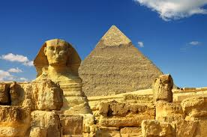
To know and understand geographical
features of Egypt.

What do you know about Ancient Egypt?

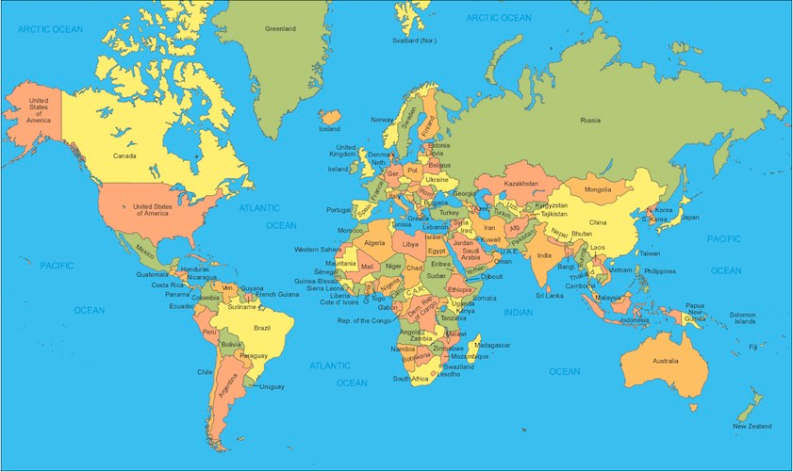
Can you find Egypt on the world map?
Draw the Equator across the world map?
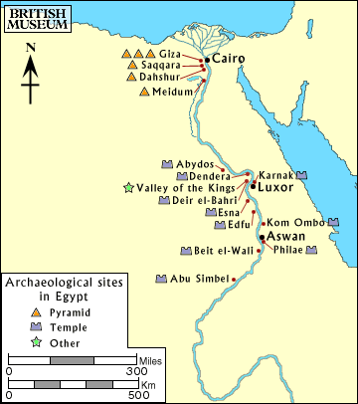
What does natural and man-made features mean?

Can you identify the physical features in Egypt?
They may be natural or man-made features.

Natural features | Man-made features.

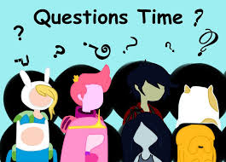
What is the capital of Egypt?
What countries boarder Egypt?
What seas boarder Egypt?
Can you name any famous landmarks in Egypt?

Use this information to create a leaflet to describe the physical features of Egypt. You can add images such as the Nile or Pyramids.

