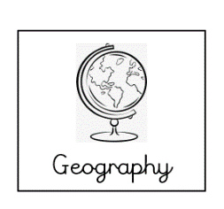**Where in the world does Shif live?**

Can you determine where Shif lives using the clues from the text?

Research what these words mean and piece the puzzle together to find out where in the world Shif lives.

|  |  |  |
| --- | --- | --- |
|  | **Meaning** | **What does this word suggest about Shif’s home country?** |
| **jacaranda tree** |  |  |
| **tsebhi** |  |  |
| **nakfa** |  |  |
| **injera** |  |  |
| **“Kemay amsikum” (greeting)** |  |  |
| **“Kemay amsika”**  **(greeting)** |  |  |

* Combining all your research, where in the world do you believe Shif lives?
* Can you locate it on a map?
* Do you know anything about the physical geography of this place already?
* Do you know anything about the human geography of this place already?