Date:______________________
Content Domains: 2b/2d
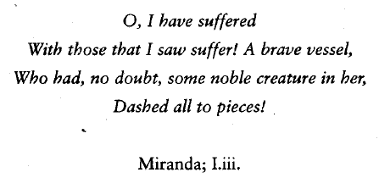
Who is Miranda linking herself to in the quote?
_______________________________________________________________________________________
What has happened to vessel in the quote?
_______________________________________________________________________________________
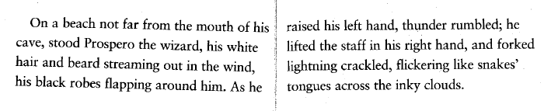
What 2 impression of Prospero does the author give? Use the text above.
Impression | Evidence
1.

2.

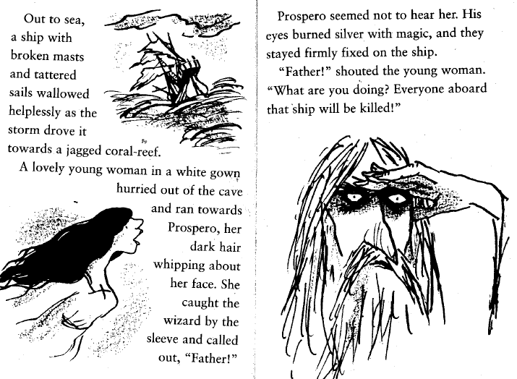
Find and copy 2 ways in which the boat is described
- _______________________________________
- _______________________________________
Which ONE words shows that the girl is in a rush
_______________________________________
How do we know that wizard and girl are related?
_______________________________________
Why does Prospero not listen to the girl? Explain your answer using the text.
_________________________________________________________________________________________________________________________________________________________________________________________________________________________________________________________________________________________________________________________________________________________________________________________________________________________________________________________________________________________________________________________________________________________________________________________________________________________________

