Date:________________________
Content Domains: 2e
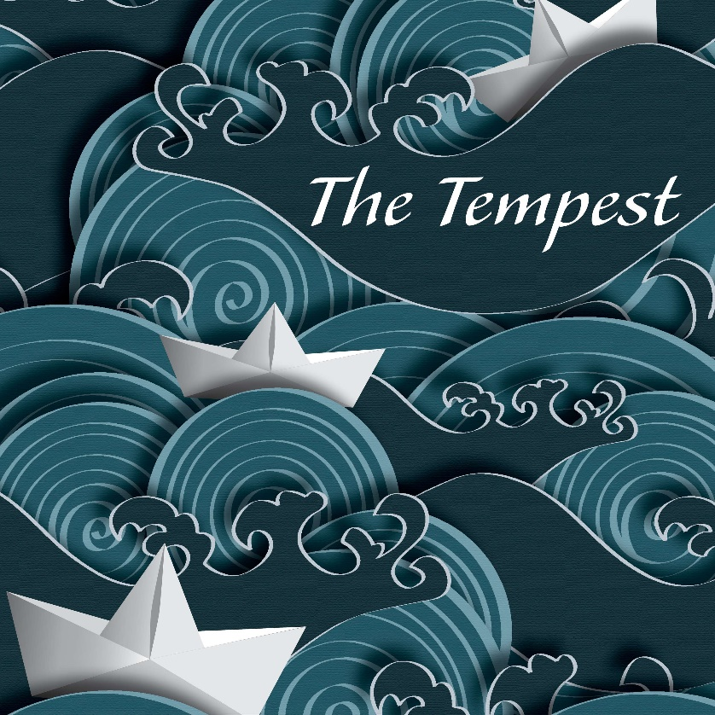

What does this image tell us about our new text? | What inferences can we make?

