Friday 3rd July 2020
History

The end of the Vikings!
The Viking Age had to come to an end at some point…but how?

Have a read of the following website to start:
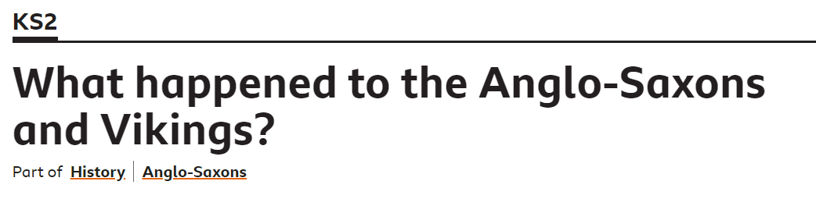

https://www.bbc.co.uk/bitesize/topics/zxsbcdm/articles/z8q487h#:~:text=Around%20the%20end%20of%20the,taking%20over%20all%20of%20England.

The Norman Conquest: What happened in 1066?
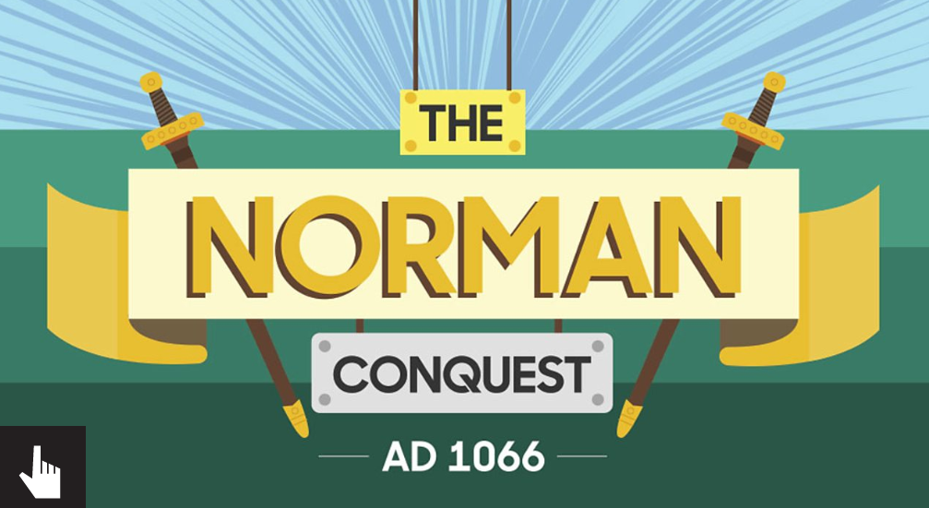
Then, follow the story of the Norman Conquest – also on BBC Bitesize

https://www.bbc.co.uk/bitesize/topics/ztyr9j6/articles/z3s9j6f

Task: Create your own comic strip to tell the story of how the Normans’ took over at the Battle of Hastings!

