History Recap
Write as many countries as you can, that were involved in the Second World War.

Now, underline the countries that were in the Allies.

Who are the 3 men below? Why were they important during the war?
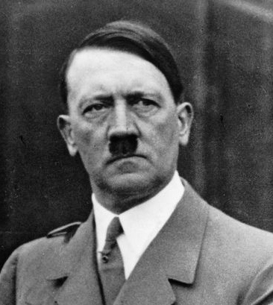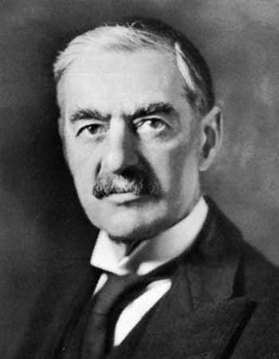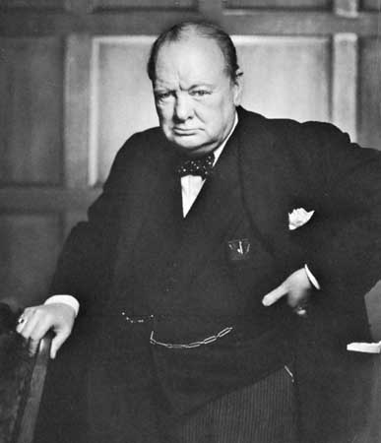

Match the Second World War vocabulary with appropriate defintion:
Spitfire |  | A person who has been moved to a safer place
Blitz |  | The name of Germany’s air force
evacuee |  | Britain’s fastest fighter plane
rationing |  | Name given to German bombing on UK cities
Luftwaffe

Now, write a definition for the word you haven’t matched to a meaning.

Between which years did the Second World War take place.

