Science
Thursday 11th June 2020
Recapping on learning so far
Have a go at the following Kahoot. It includes questions from previous year groups and learning from Year 5. Enjoy!

https://kahoot.it/challenge/05999287?challenge-id=2246dd3c-1002-4313-8b52-169458a58e25_1591530678424

What are irreversible/reversible changes?
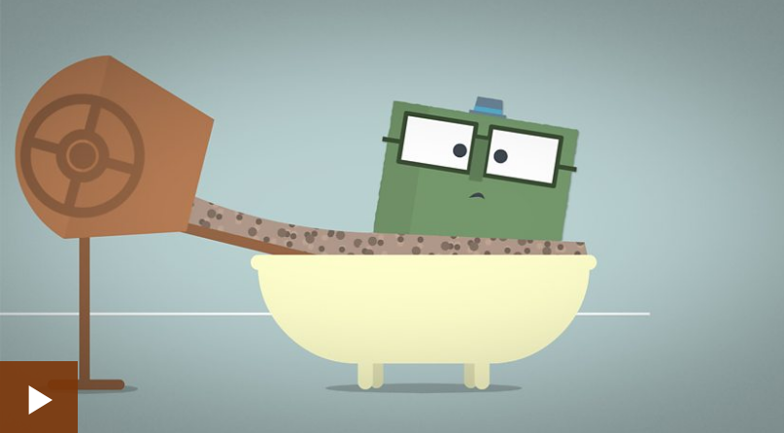
Watch the following BBC Bitesize clip to find out all about reversible and irreversible changes. Create a table/poster/information leaflet explaining each one and give examples.
https://www.bbc.co.uk/bitesize/topics/zcvv4wx/articles/z9brcwx
You could also try some of the changes yourself, take pictures and add them to Class Dojo or Google Classroom to demonstrate your scientific observations.

