Monday 15th June
Subtracting Fractions with the same denominator

When subtracting fractions with the same denominator, the denominator stays the same and you just subtract the numerator.
e.g. 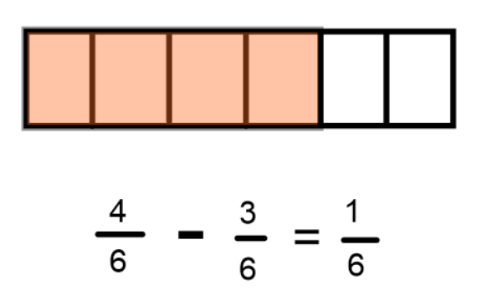

$$\frac{4}{6 }are shaded, so take 3 of those away. There is\frac{1}{6} left.$$

Have a go at these:-
(Remember to try to simplify the answers if you need to!)
- $\frac{6}{10}-\frac{5}{10}=$
- $\frac{7}{9}-\frac{1}{9}=$
- $\frac{3}{4}$− ¼ =
- $\frac{9}{12}-\frac{5}{12}=$
- $\frac{12}{15}-\frac{2}{15}=$
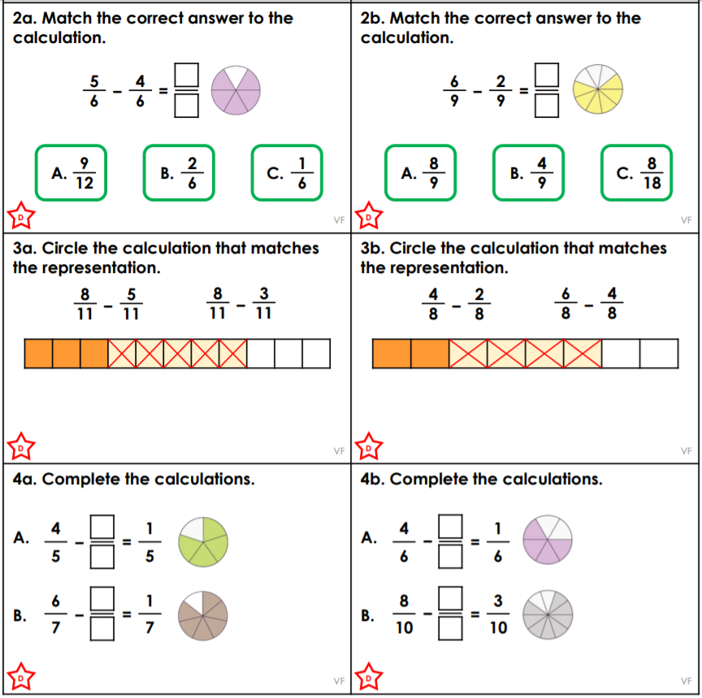
Challenge
