Tuesday 16th June
Subtracting fractions with different denominators.
Re-cap – how did we add fractions when the denominators were different?
How did we make the denominators the same?
What were the rules we used?

So
To subtract fractions with different denominators, we still need to make the denominators the same.
e.g. 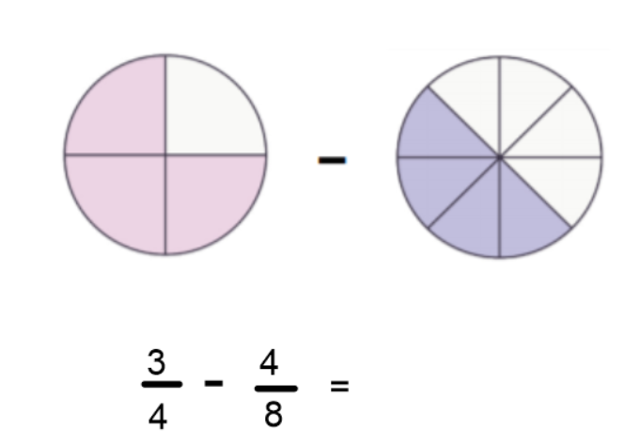
We need to turn the $\frac{3}{4} into 8ths.$ To do this, we double the denominator, then double the numerator. (Whatever we do to the bottom, we must do to the top.) We can then subtract the numerators.
$$\frac{6}{8}-\frac{4}{8}=\frac{2}{8}$$
We can simplify $\frac{2}{8}because 2 and 8 are multiples of 2. Divide 2 and 8 by 2.$
$$\frac{2}{8}=\frac{1}{4}$$
Your Turn
Have a go at subtracting these fractions:
- $\frac{1}{2}-\frac{1}{4}=$
- $\frac{5}{8}-\frac{1}{4}=$
- $\frac{2}{3}$−$\frac{2}{9}=$
- $\frac{4}{5}-\frac{3}{15}=$
- $\frac{4}{7}-\frac{4}{14}=$

See next page for varied fluency questions
