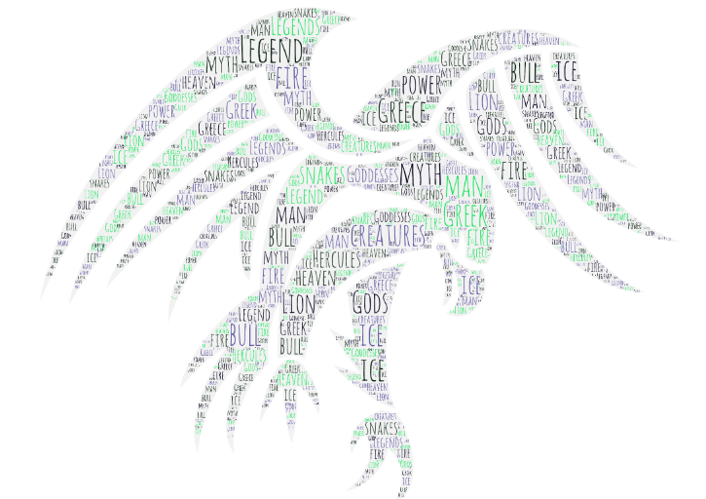
Monday 15th June
Write a prediction about our next unit of English. What do you think we are learning about? Remember to justify your answers with evidence from the image!

I predict that…
I believe this because…
I can see in the word cloud…
After having a discussion with my family…

