Monday 22nd June 2020
- 3873 – 1745 =
- 8923 + 991 =
- 4421 + 832 =
- 783 – 662 =
- 5427 + 3658 =
- 9002 – 7772 =
- 8000 – 3672 =
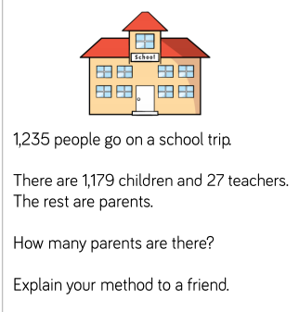
Mr Wallis has 67 pies.
At the weekend he is having a party so he buys a further 5632 pies.
At the weekend his friends eat 2851 of the pies.
How many does he have left?

