Monday 22nd June 2020
This week you are going to write a non-chronological report about the Greek mythical creature which you have created/ designed yourself!
When we write a non-chronological report you need to use generalisers (use the PowerPoint to help you understand what a generaliser is).
Can you practise writing generalisers to describe your class? Here is a word mat to help you, there are also some examples!
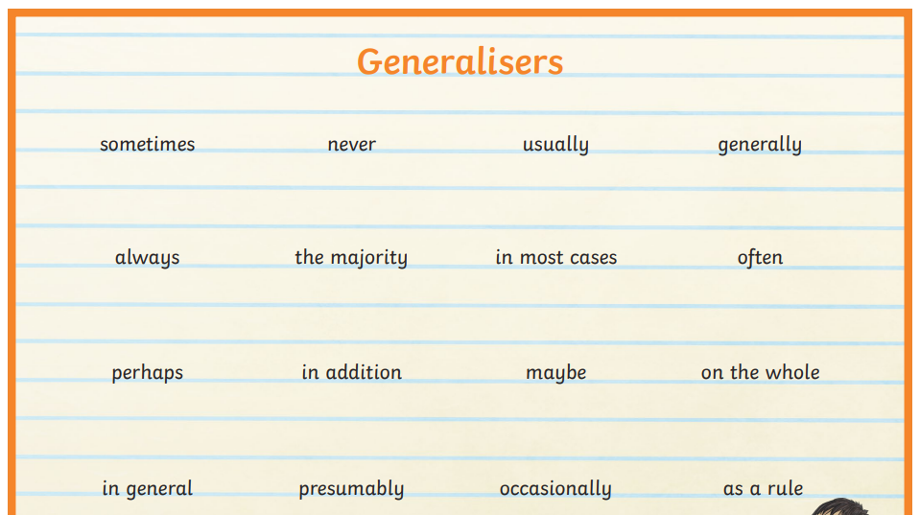
Usually, Fearless Foxes win the attendance award because they arrive on time at school and they are all in school!
In Powerful Pandas, Mr Wallis is always wearing his trainers as he wants to go outside and play some cricket!
Often in Flourishing Flamingos, children are seen dancing and singing as Miss Petty loves to sing and act!
Now, can you write your own…?

