Monday 22nd June 2020
English

Last week, Mrs Langley explained how to box up your newspaper article using the boxing up grids we use in class. If you missed this, go back and watch the video to help you:
https://www.loom.com/share/72bcb949f7f14bca9cef15c6934df651
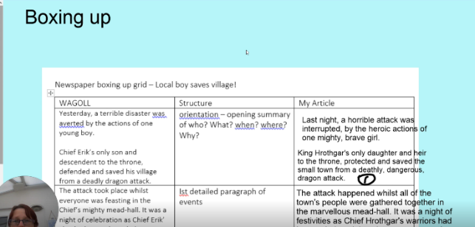

Opening
Today, you are going to write the opening of your article, using your boxing up grid to help you.
It is important that the opening of your article includes the 4W’s. You need to summarise:
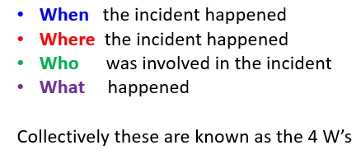

Look at the following example:
Disaster struck last night in Ashtead when a massive 10kg bag of wine gums was maliciously stolen from 5H classroom by a violent gang of thieves.
When: Last night
Where: Ashtead, 5H Classroom
Who: Violent gang of thieves
What: A massive 10kg bag of wine gums was maliciously stolen

Now see if you can identify the 4 WW’s in my opening…
Last night, a horrible a horrible attack was interrupted by the heroic actions of one mighty, brave girl.
King Hrothgar’s only daughter and heir to the throne, protected and saved the small town from a deathly, dangerous dragon attack.
When:
Where:
Who:
What:

Now have a go at writing the opening to your newspaper article checking that you have the 4W’s. Make sure to proof read, edit and up level where you can.

