Monday 22nd June
Adding mixed numbers with the same denominator.

Re-cap – adding fractions
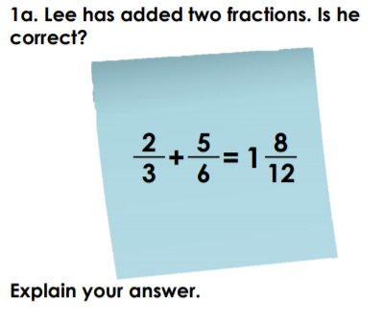

Today we are going to learn how to add mixed numbers.
A mixed number is a whole number and a fraction.
So how would we add these?
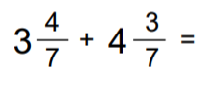
Rather than making it too complicated, we can add the whole numbers and the fractions separate.
Pretend the whole number is not there at first.
$$\frac{4}{7}+\frac{3}{7}=\frac{7}{7}$$
We know $\frac{7}{7}$ is a whole.
3 whole + 4 wholes = 7 wholes
Plus we made another whole by adding the fractions.
The answer is therefore 8.

For another example see the loom video below.
https://www.loom.com/share/a57b6d167df54fbc8144641787c1a759

Your turn – Have a go at adding these mixed numbers
