Monday 29th July
Cold write – Rags to Riches Story

Last week you all did really well with your newspaper reports. The year 5 learning team were really pleased with them and with what you had remembered.
As we are about to start another new unit of work for English, we would really like you to do us a cold write so that we can assess your writing and really see your progress.
You are going to write a Rags to Riches story. Think about our previous topics and how the main characters have gone from having nothing, to having some form of riches - not just money, but happiness or fame. Think about your newspaper reports too and what they were about.
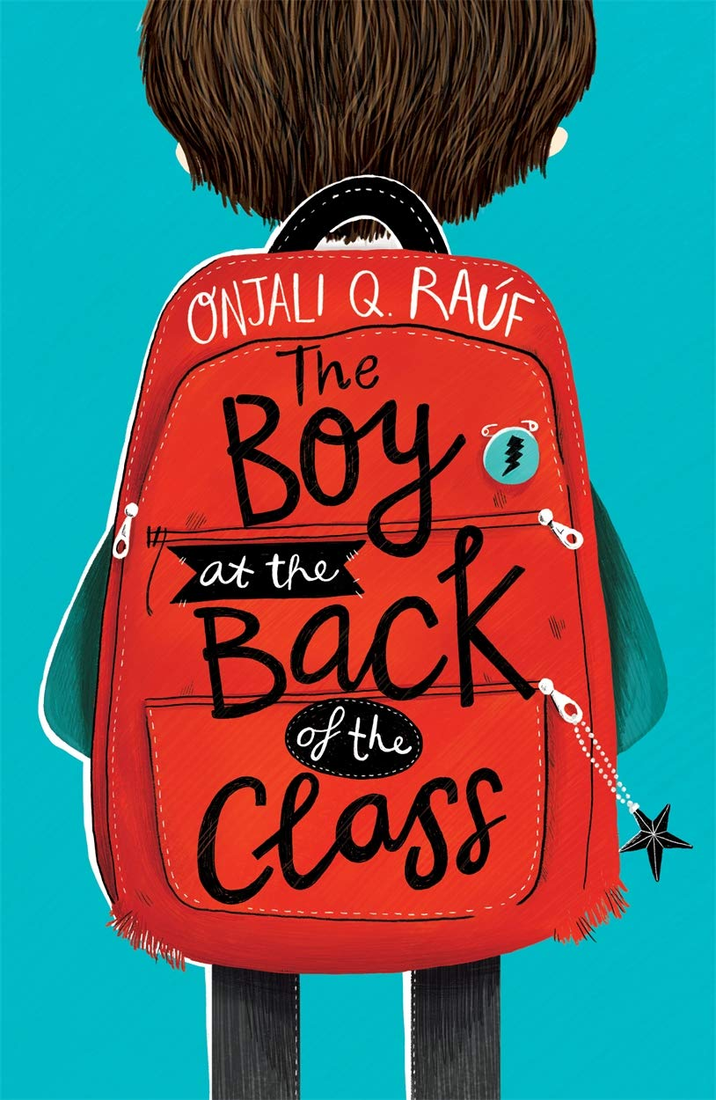
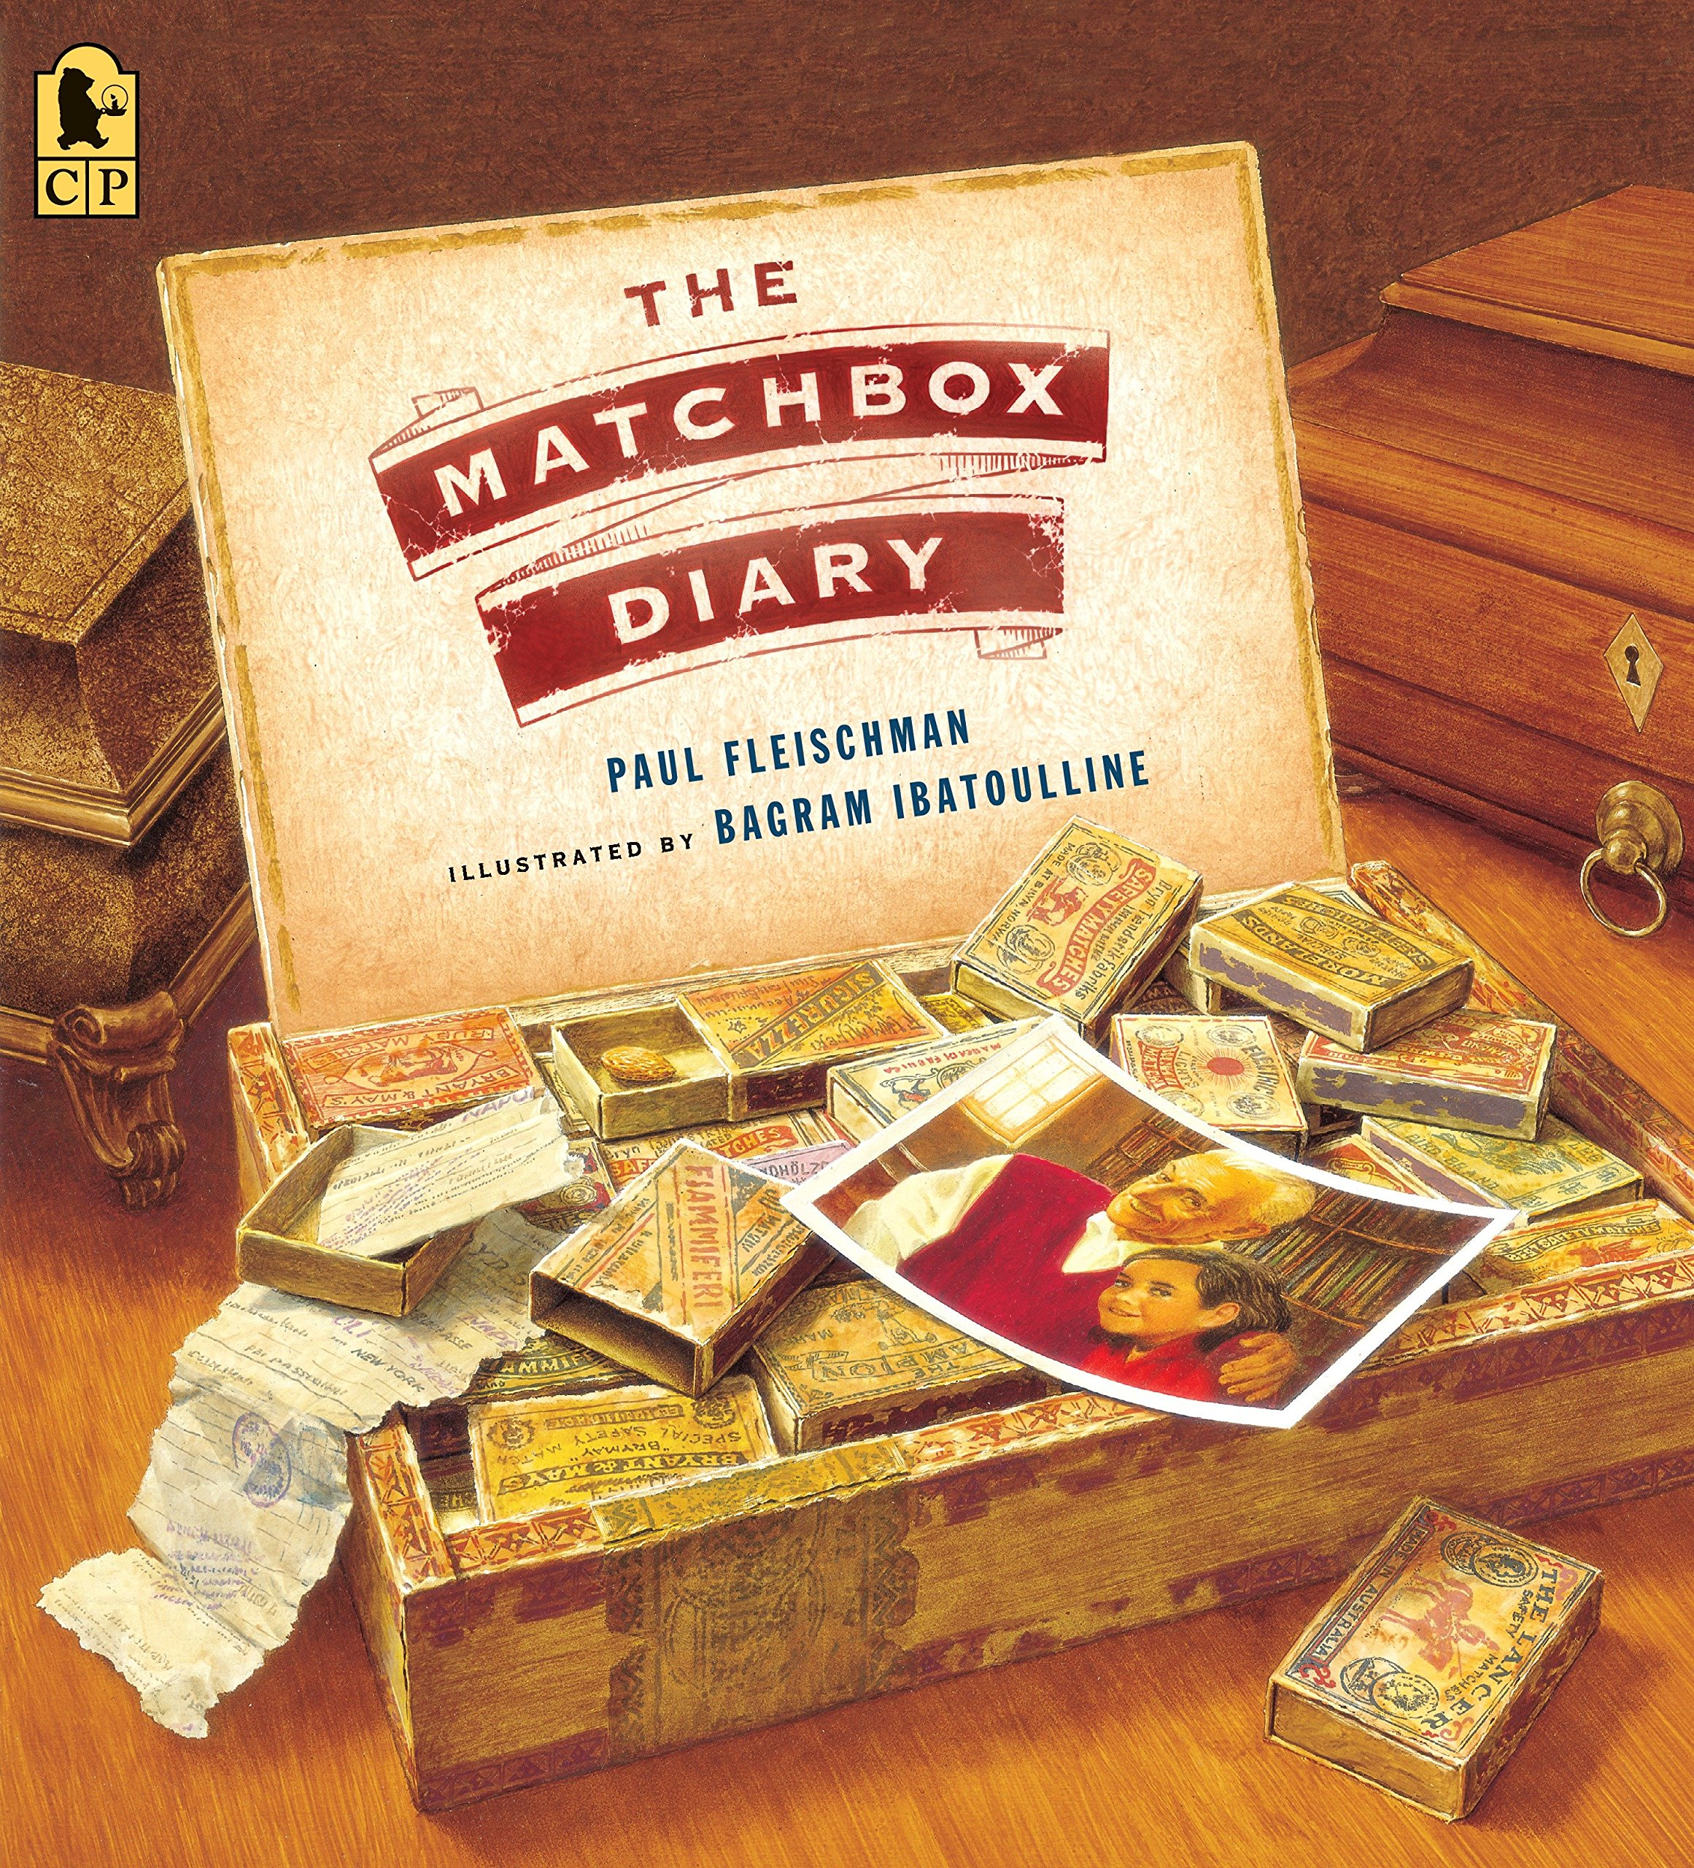
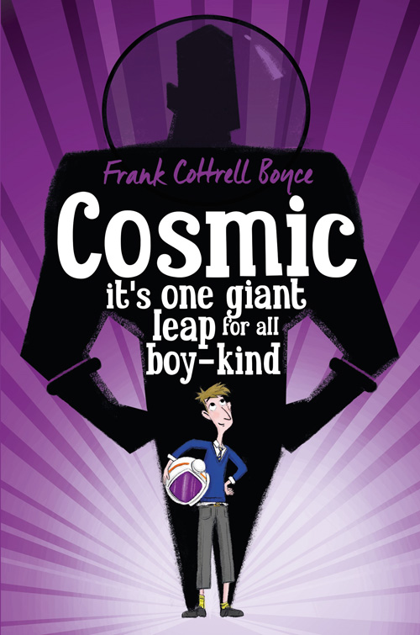

Your task:
Cold Write
Write a rags to riches story about a character who starts off pitiful but ends up a hero/heroine. Think carefully about:
- How you introduce your character
- How is it they are successful? Is it purposeful or an accident?
- What difficulties do they have to overcome?

