Monday 29th June
Converting Measures
We are going to learn how to convert between different units of measure.
You need to learn some units for measuring. Which units of measure would you use to measure the following things? Match them up

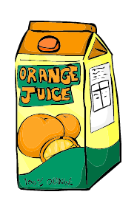
Metres or kilometres

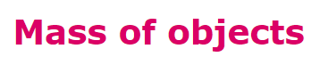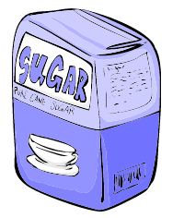
Millilitres or litres

Grams or kilograms
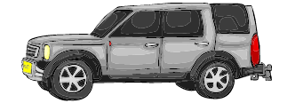

You need to know:
1kilograms = 1000grams
1kilometre = 1000metres
1litre = 1000millilitres

How would we work out what 1$\frac{1}{4}$ kg is in grams?
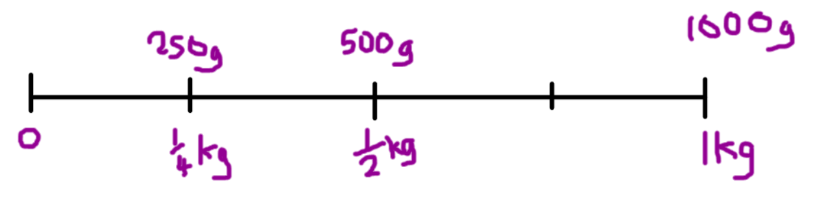
If there are 1000g in 1kg. Then in ¼ if a kg there are 250g
Add them both together.
1000g + 250g = 1250g

Watch the video for an explanation
https://www.loom.com/share/0b2b8fedd40b46578a15f3e93a418b4b

What is 2250ml in litres?
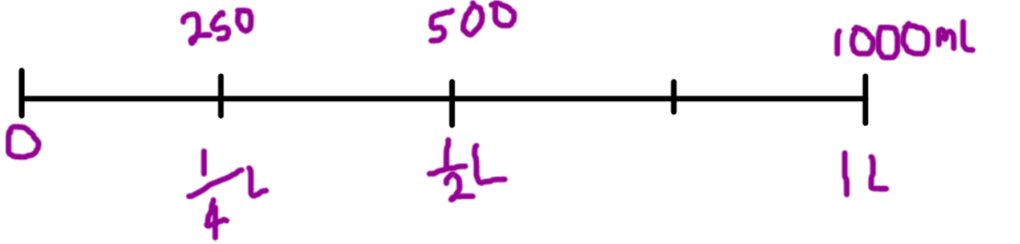

Watch the video for the explanation.
https://www.loom.com/share/69d308bd31a44035baa0c28c34e89a70

Your Turn
Complete the conversions below:
- 5000ml = Litres

- $\frac{1}{4}$ Litre = ml

- $2500ml=$ Litres

- 3250ml = Litres

- 6.5 Litres = ml

What about 1200ml in Litres?
You can use your place value to convert between measures.
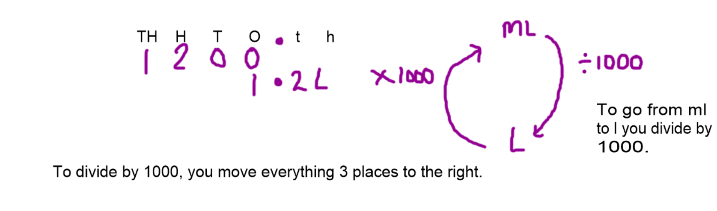

Watch the video for an explanation
https://www.loom.com/share/24ed4d7638294350b87d9d6902c425cc

Your turn
Convert these ml to l
- 2300ml = Litres

- 1850ml = Litres

- 3500ml = Litres

Now try converting from Litres to ml by multiplying by 1000. Use your place value grid to help you.

- 1.3 Litres = ml

- 4.25 Litres = ml

- 2.75 Litres = ml

- 1.5 Litres = ml

