Monday 29th June 2020
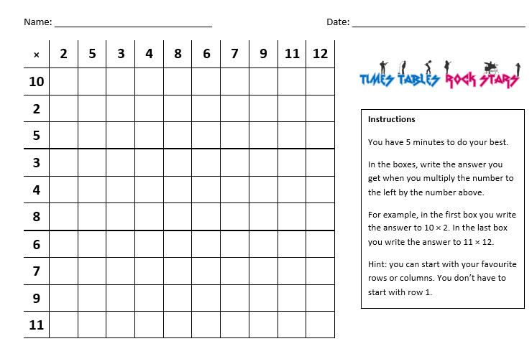
Remember time yourself to see how many you get. Have a 7 minute rest and have another go. See if you can improve your score after each sheet.

