Date:_____________________________
Content Domains: 2d/2b/2g
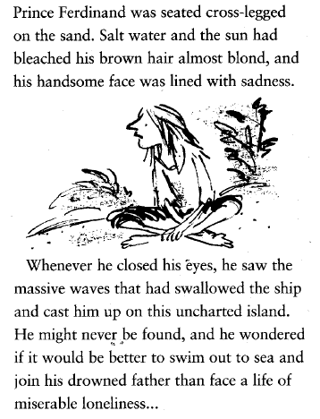
Why is Prince Ferdinand upset? Explain your answer clearly using the text for support?
_________________________________________
_________________________________________
_________________________________________
_________________________________________
_________________________________________
_________________________________________
_________________________________________
_________________________________________
_________________________________________
_________________________________________
_________________________________________
_________________________________________

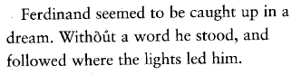
How do we know that Ferdinand is in a trance?
____________________________________________

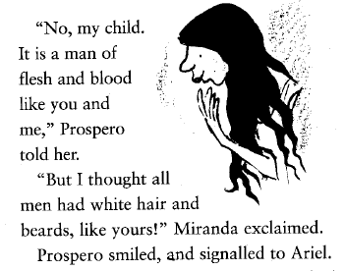
Why is Miranda confused by the sight of Ferdinand? Explain your answer clearly using the text for support?
_________________________________________
_________________________________________
_________________________________________
_________________________________________
_________________________________________
_________________________________________
_________________________________________

