Date:__________________________________
- Standing in the desert looking out into the horizon.
- Realising that he in in Egypt about to achieve his dream.
- Spending hours doing research
- Unable to find anything
- Being told his is a failure
- His men refusing to help him
- Walking through the desert alone
- Seeing the entrance to the tomb
- Walking down the corridor in darkness
- Seeing a glint of gold
- Discovering the treasure
- Seeing Tutankhamun for the first time
- Being celebrated as a hero
LI: to be able to understand a characters emotional journey throughout a narrative
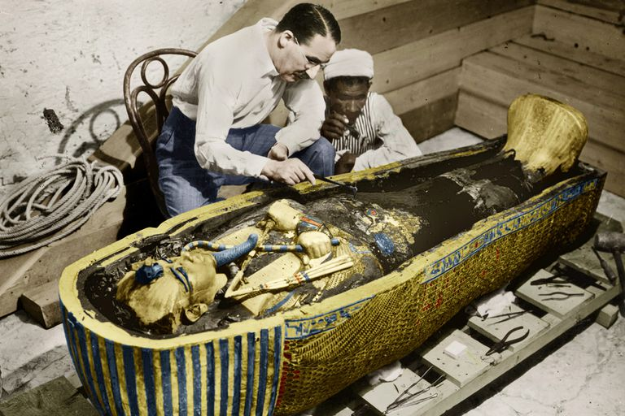
I will be successful if:
- I can recall key events
- I can infer a characters emotion at specific points
- I can use synonyms for emotions
Happy
Sad

Plot The Howard Carter’s emotions during the story
Time

