Monday 18th June
Cold write – Newspaper report.

Watch this film clip from “How to train your dragon”.

https://www.youtube.com/watch?v=DBUXGB_L5q8&t=15s

What is happening? What can you see? Where is it taking place? Who is there? Why are they there? When is it taking place?

You haven’t done an assessed piece of writing for quite a long time, so please have a go at writing a cold task news paper report. We would all love to read your own writing and to see the progress you have made. Once you have done your cold write, we will work through a unit of work on writing newspaper reports.

Cold Write
Write a newspaper report based on the film
clip of ‘How to train your dragon.’
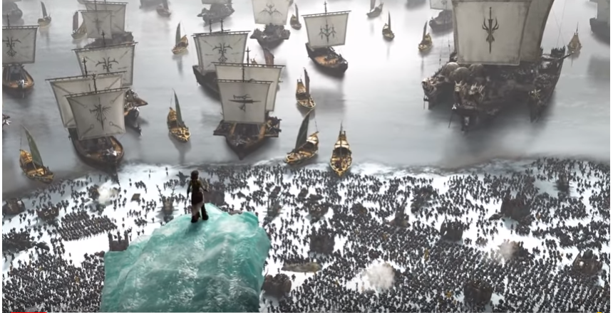

Think carefully about:
- The 5 w’s – who? what? when? where? why?
- Details of what happened and the order they happened in.
- Who the witnesses were that could give you a quote.
- How to write reported and direct speech

Your audience is the year 5 team on dojo/ google classroom so you are writing in a formal way. Your purpose is to inform them about the event and give them detail about it so that they feel shocked by what’s happened and then proud of Hiccup.

