Monday 8th June
Reading – prediction
During the reading lessons this week, what do you think you will read about? What sort of things/ facts do you think you will find out?

Make a prediction based on the unit title.

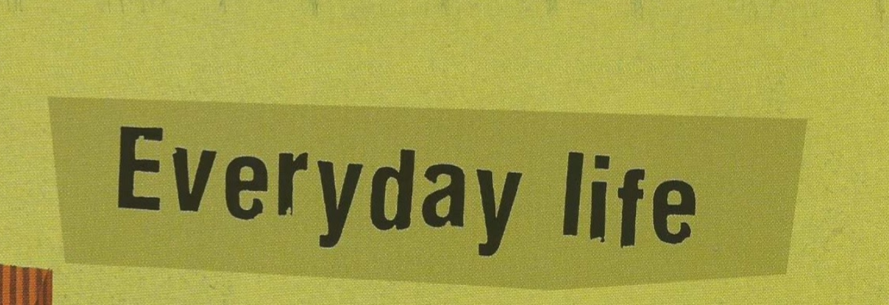

Remember to use modal verbs (could, would, should, might, will) and conjunctions (however, because, if, when, while)

Now read the introduction to the unit. Add to or change your prediction.
