https://www.bbc.co.uk/bitesize/topics/zsq7hyc

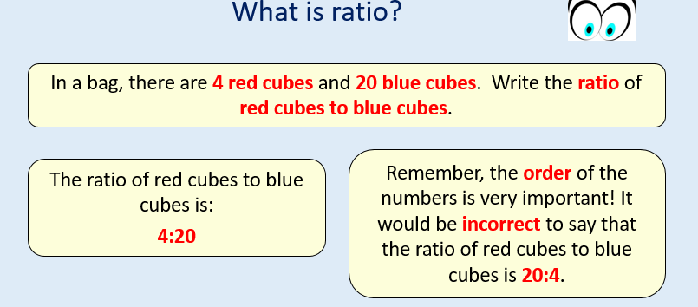
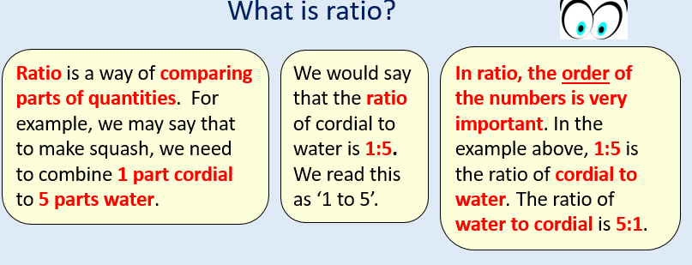
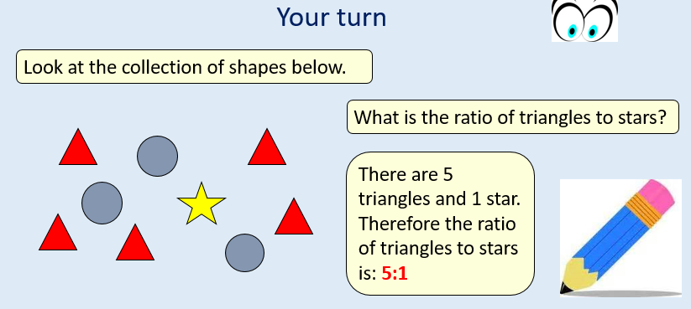

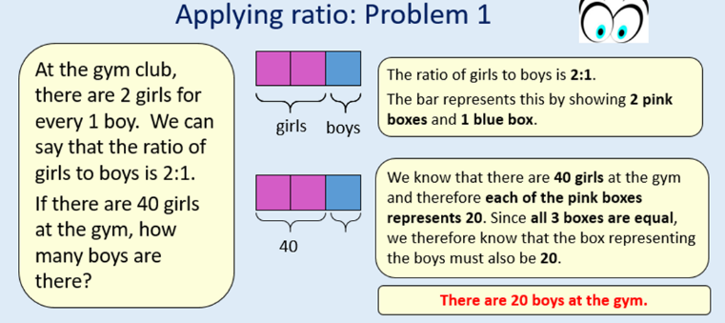
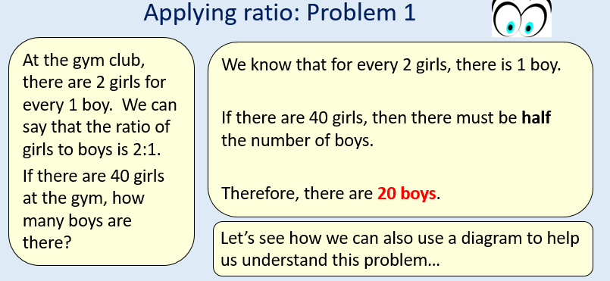

Please sure the power point on the website if you need any further help.

Monday
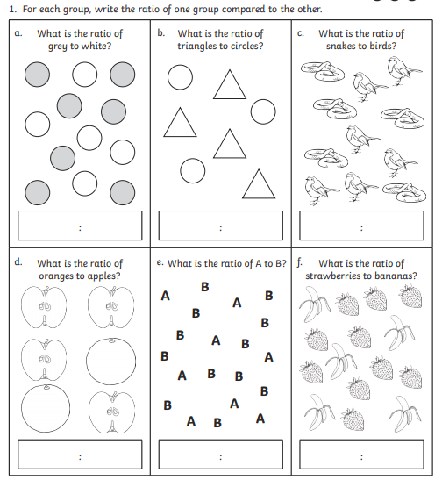

- There are 8 cubes in a bag. Three cubes are red and the rest are black. What is the ratio of black to red cubes? Can you draw a diagram to represent this?

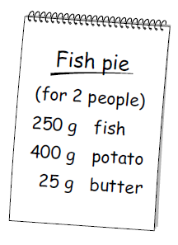
- Here are the ingredients for a fish pie for 2 people.

Steph makes a fish pie for 3 people. How many grams (g) of potato will she need to use?

- In a school, the ratio of boys to girls is 2:3. There are 80 boys in the school. How many girls are there?

