Date:_____________________________
Content Domains: 2d/2b
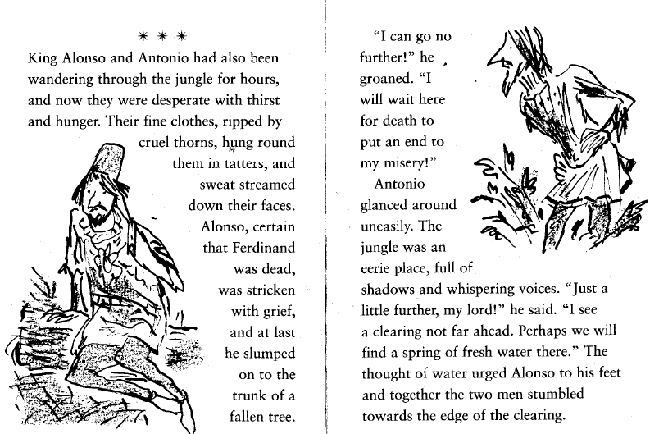
How do we know that they have been walking for a long time? Find and copy a phrase
_______________________________________________________________________________________
How do we know that they are hot? Find and copy a phrase
_______________________________________________________________________________________
Why did Alonso lose hope? Explain your answer using evidence from the text.
_______________________________________________________________________________________
_______________________________________________________________________________________
_______________________________________________________________________________________
_______________________________________________________________________________________
_______________________________________________________________________________________
_______________________________________________________________________________________
How does Antonio get Alonso to continue to move?
_______________________________________________________________________________________
_______________________________________________________________________________________

