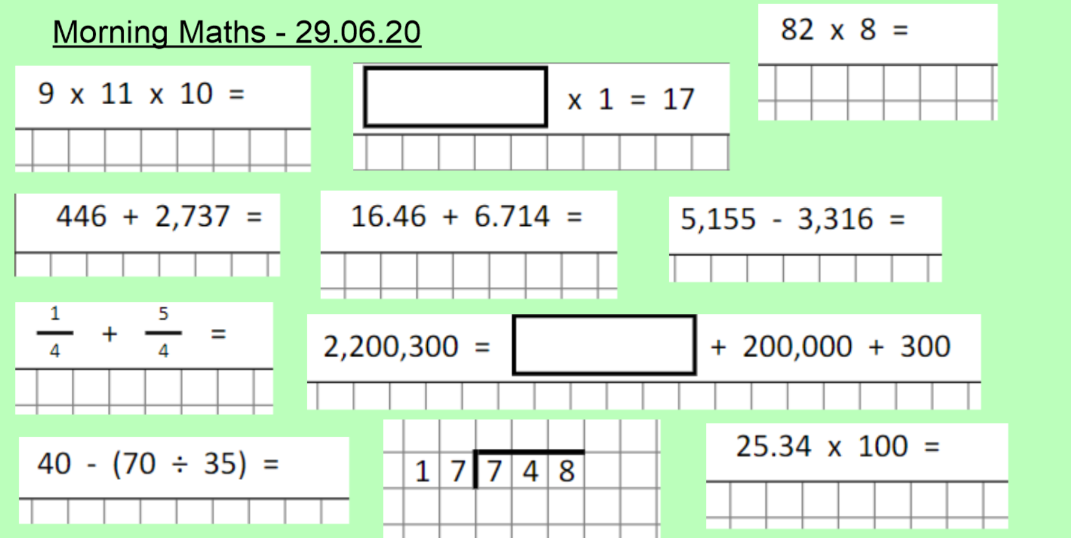

If you need help with any of the above questions, please ask on dojo or classroom. Mrs Langley will make you a loom video to model how it’s done.

