Morning Maths
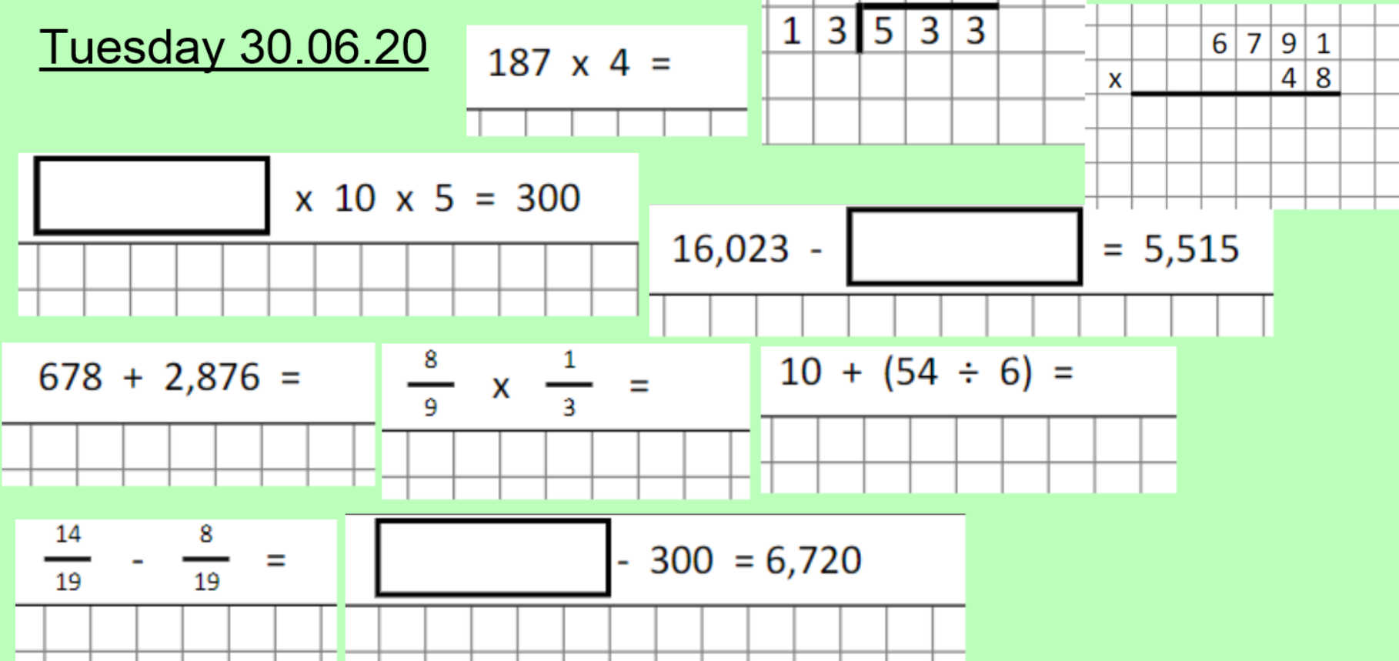

If you are stuck with any of the maths above, please ask on dojo or classroom.

