Morning Maths

<https://www.loom.com/share/d1e7cb12790c42bb8ee1fb97f480f959>

Video to explain how to do question 1

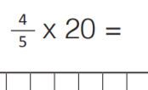

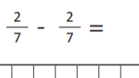 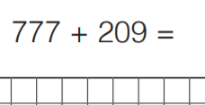

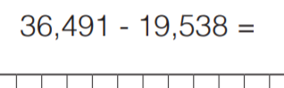

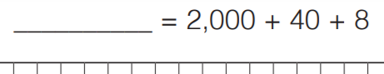

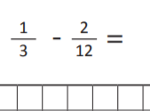 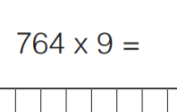

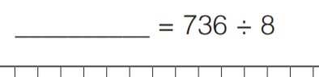

If you are stuck with any questions, please do not hesitate to ask for help. We can provide loom videos on how to do these if you need us to. Not being able to do something is ok!