Monday 29th June
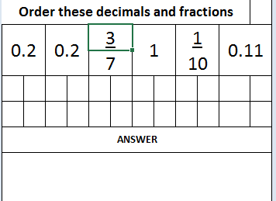
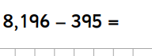
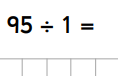
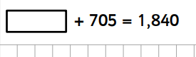
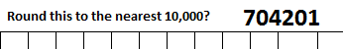
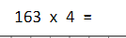
Morning maths

