**Morning maths**

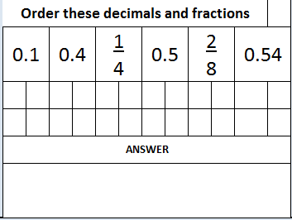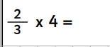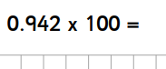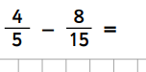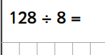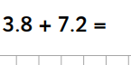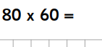

To convert 2/8 into a decimal you can simplify it or do 2 divided by 8.

See loom video for how to do 2 divided by 8.

<https://www.loom.com/share/9ce468f37e77498dae393f737e23a7db>