Music
Lesson 5

Texture
Musicians mix and layer the sounds they are playing to create texture. This makes the piece more interesting to listen to.
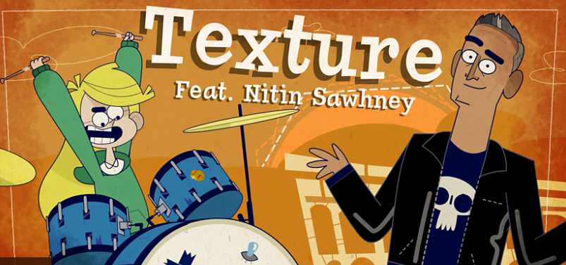
https://www.bbc.co.uk/bitesize/topics/zcbkcj6/articles/z9ffng8

Activity 1 - Extended listening
Listen to You Are The Sunshine In My Life by Stevie Wonder. Focus on the texture.
LISTEN OUT FOR: The hook: "You are the sunshine of my life". The texture changes slightly in each verse and chorus with slightly different brass lines should say instrumental lines and use of backing vocals.

Activity 2
When you start making your own music, you can take inspiration from the sounds around you. Create your own soundscape from making different sounds in your home at the same time and see what you can come up with. You do not need instruments for this you could use your voice or objects to create different sounds.
You can record a video/sound clip and send them in an email to your class teacher!

