Wednesday 1st July 2020
PE

https://www.afpe.org.uk/thisispe-supporting-parents-to-teach-pe-at-home/
Lesson 11 – Catching

Catching
For this lesson, you will need:
- Rolled up socks
- A pillowcase filled with socks

Activity 1 – large object
Fill the pillowcase with rolled up socks. With a partner, ‘push’ the object back and forth

Develop this by throwing to the side or higher up in the air.
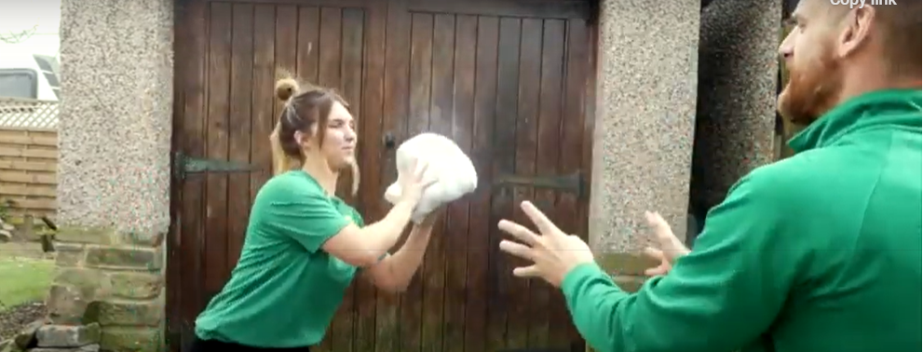
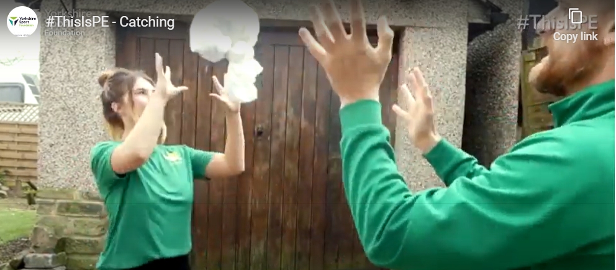

The next step is to add a clap before catching.
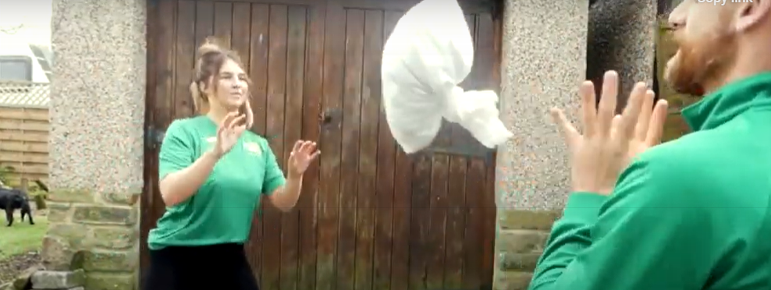
Activity 2 – smaller object
This time, only use the rolled up socks. You need to change your catching technique to create a ‘nest’ with your hands that you bring in to your chest. This will cushion the object.
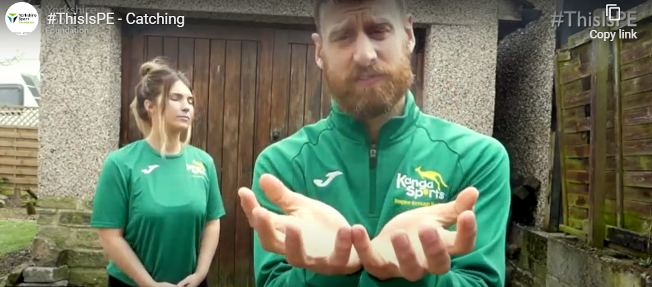

Try throwing it to the side.
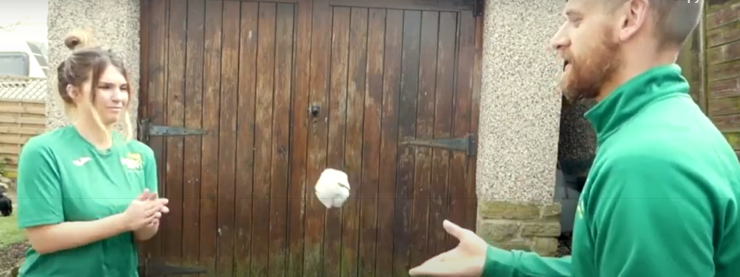
And again, clap before catching

Activity 3 – One handed catch
Still create a nest with your hand and when you have caught the object, bring it into your chest.
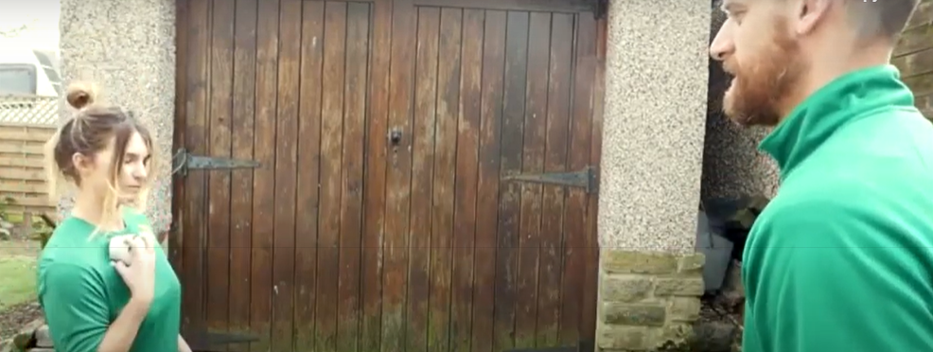

Activity 4
Play catch tennis!
1 point for every catch and 1 point each time your opponent drops it.
You can play over a chair, table, ironing board etc.
Keep count of your own score!
