The Academy at St. James

Progression in Teaching and Learning Calculations

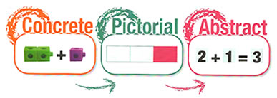
Essential thought process for calculating:
Always model with manipulatives
1 Estimate first
2 Can I do it in my head?
3 Can I do it with practical equipment?
4 Can I do it with some jottings?
5 Which written method do I need?

Concrete, Pictorial, Abstract

6 Have I checked my answers? Can I
use the inverse?
Involve problem solving as much as possible

Always look for real life applications

Progression in the use of manipulatives to support learning
USE IT!

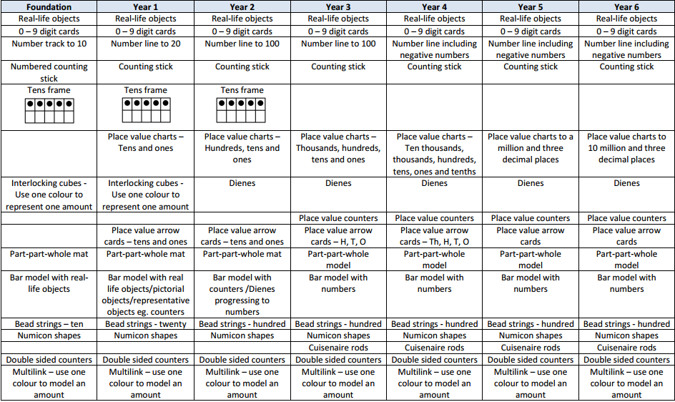
Maths Working Wall
DISPLAY IT!

BUILD IT! | Use real life objects on the display which the children can see, touch and feel. Encourage them to use the objects to explore the maths concepts.
DRAW IT! | Show a pictorial representation of the concept. Encourage the children to draw it in their books. Making jottings and representations is a good thing! | 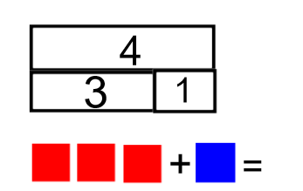
SOLVE IT! | Show the mathematical representation of the concept. | 3 + 1 = 4 4 = 1 + 3  1 + 3 = 4 4 = 3 + 1  4 – 1 = 3 3 = 4 - 1  4 – 3 = 1 1 = 4 - 3
PRACTISE IT! | Encourage the children to practice the concept.  Interactive opportunity – ask the children to respond to questions, encourage them to add and explain what they know and leave them homework to take to master the concept. | 4 + 1 = ?  5 + 2 = ?  2 + 5 = ?  1 + 4 = ?
CHALLENGE IT! | Set a challenge to be solved (Mastery materials).  Interactive opportunity – leave the manipulatives out for the children to use in their investigation/ problem solving. | 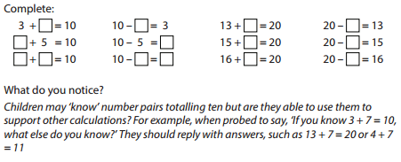
SAY IT! | Use and display the vocabulary related to the concept. | Add, addition, plus, sum, more, increase, total, altogether
Classroom Visual Prompts
SEE IT!

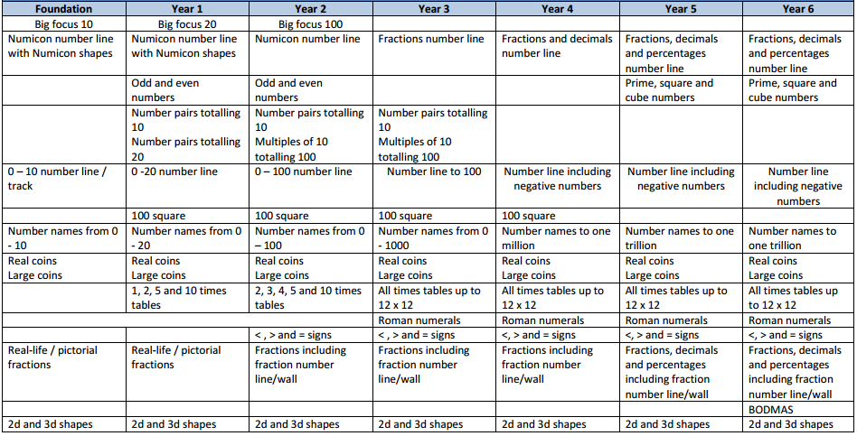

Progression in the teaching of Counting – Foundation Stage

Pre-counting  A focus on the concept of more or less. Develop these concepts through comparison only and no counting is involved. | Ordering  Reciting number names in order – forwards and backwards from any starting point. | One to one correspondence  Matching number words to objects.  To help with co-ordination, move the objects as they count, use large rhythmic movements or clap as they count. | Cardinality (knowing the final number counted is the total number of objects)  From a large amount of objects, count out a smaller group – knowing that the number they stop counting on is the total number of objects in their group.
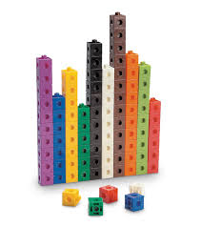Let the children sort groups of objects explicitly using the language of more and less.  Which group has the most?  Which group has the least? | Count orally on a daily basis. Rote count to begin with so that the children are able to understand number order and can hear the rhythm and pattern. Use a drum or clap to keep the beat. 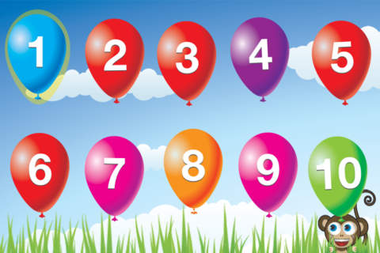 | Sing counting songs such as 5 little ducks, 1,2,3,4,5…, 10 green bottles etc so that the children have visual and kinaesthetic resources.  Play counting games – moving along a track, knocking down amounts of skittles etc.  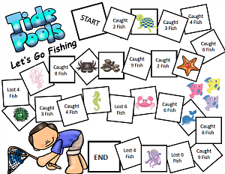 | Give the children real life objects i.e a fruit bowl of fruit, to count. Let them move the objects as they count them.  How many bananas are there in my fruit bowl?  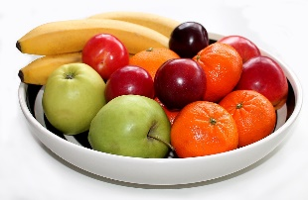
Substitising (recognise small numbers without counting them)  Recognise numicon shape dot patterns, dot patterns on dice, patterns on playing cards and small groups of shapes stuck on to cards. | Abstraction  Counting anything – mixtures of different objects, or similar objects of very different sizes.  Children find it difficult to count objects they can’t move, touch or see (They move around) | Mastery  Children need to know that no matter what order the objects are in, there is still the same amount there. They can be rearranged and the amount doesn’t change. | End of year counting expectations  • count reliably to 20  • count reliably up to 10 everyday objects  • estimate a number of objects then check by counting  • use ordinal numbers in context eg first, second, third  • count in twos, fives and tens  • order numbers 1-20  • say 1 more/ 1 less than a given number to 20
Play flash card games, order dice displaying different numbers, order numicon and say the numbers out loud etc. | Give the children pictures and ask How many… questions.  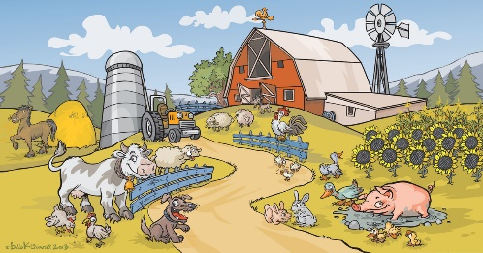  How many sheep are there? How many ducks are there? | 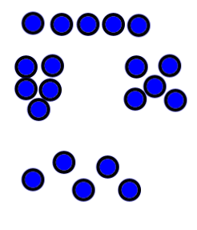  No matter how the 5 objects are arranged, they are still 5 objects.

Progression in the teaching of Place Value

 | Year 1 | Year 2 | Year 3 | Year 4 | Year 5 | Year 6
Place Value | Count, read and write numbers to 100 in numerals  Identify and represent numbers using objects and pictorial representations | Count in steps of 2,3 and 5 from 0 and in 10s from any number  Read and write numbers to 100 in numerals and words  Recognise the place value of each digit in a 2-digit number  Identify, represent and estimate numbers using different representations  Compare and order numbers from 0 to 100 using < and >  Use place value facts to solve problems | Count in 4, 8, 50, 100, find 10 or 100 more or less  Read and write numbers to 1000 in numerals and words  Recognise the place value of each digit in 3-digit numbers  Identify, represent and estimate numbers using different representations  Compare and order numbers up to 1000  Use place value facts to solve number and practical problems | Count in 6,7,9,25 and 1000, find 1000 more or less than a given number  Count backwards through zero to include negative numbers  Recognise the place value of each digit in a 4-digit number  Order and compare numbers beyond 1000  Identify, represent and estimate numbers using different representations  Round any number to the nearest 10,100 or 1000  Use place value to solve problems  Read Roman Numerals up to 100 | Count on and back in steps of powers of 10 for any given number to 1,000,000  Interpret negative numbers in context  And count on an back across zero into negative numbers  Read, write, order and compare numbers to at least 1,000,000 and determine the value of each digit  Round any number up to 1,000,000 to the nearest 10,100,1000, 10,000 and 100,000  Read Roman Numerals uo to 1000 | Read, write, order and compare numbers up to 10,000,000 and determine the value of each digit  Round any whole number to a required degree of accuracy  Use negative numbers in context and calculate across zero  Solve problems involving the above
Progression in models and images for Place Value

Objective | Concrete  BUILD IT/ USE IT! | Pictorial  DRAW IT! | Abstract  SOLVE IT!
Represent numbers 0- 10 with objects | 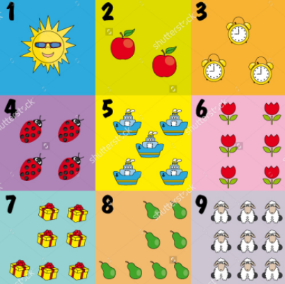 | 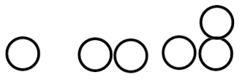 | 0,1, 2, 3, 4, 5, 6, 7, 8, 9, 10
Recognising the value of each digit in a 2-digit number | 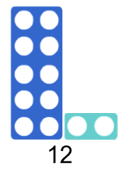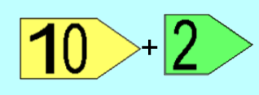  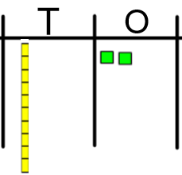  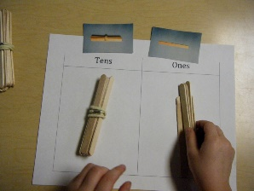 | 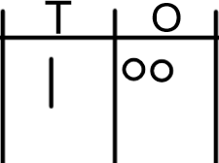 | 10 + 2 = 12  One ten and two ones  twelve
Comparing and ordering 2-digit numbers | 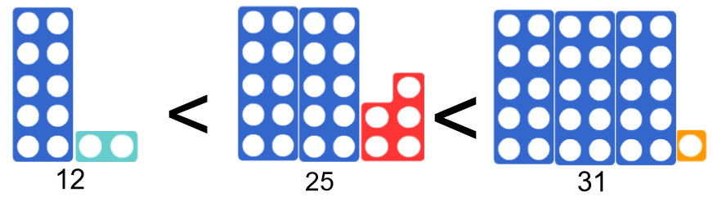  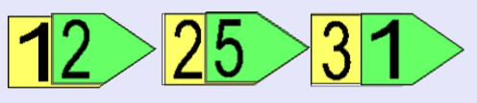  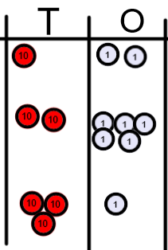 | 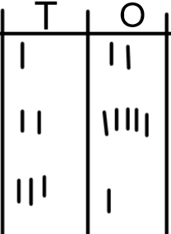 | 12 < 25 < 31  - Compare the tens first, then compare the ones!
Recognising the value of each digit in a 3-digit number | 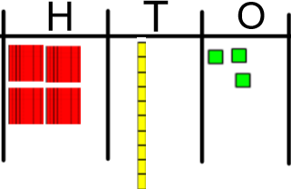  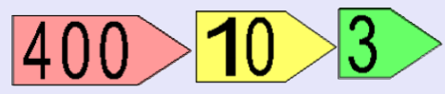 | 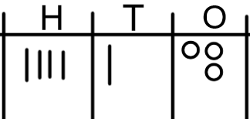 | 400 + 10 + 3  413  Four hundred and thirteen
Ordering and comparing 3-digit numbers | 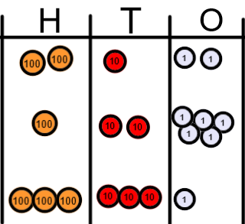  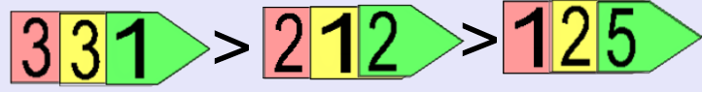 | 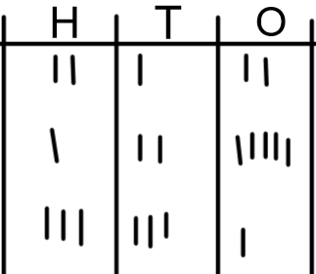 | 331 > 212 > 125  - Compare the value of hundreds  - Compare the value of tens  - Compare the value of ones
Recognise the value of each digit in a 4-digit number | 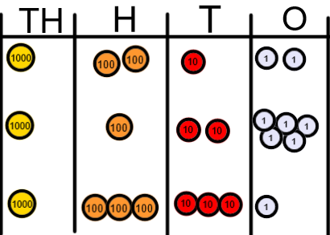 | 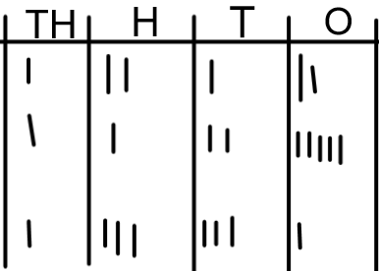 | 1000 + 200 + 10 + 2 = 1,212  1000 + 100 + 20 + 5 = 1,125  1000 + 300 + 30 + 1 = 1,331  One thousand, two hundred and twelve  One thousand, one hundred and twenty-five  One thousand, three hundred and thirty-one
Rounding numbers to the nearest 10 | 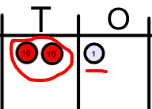  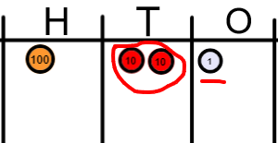 | 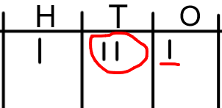 | 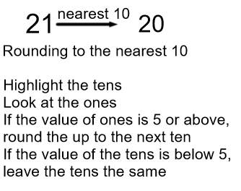
Rounding numbers to the nearest 100 | 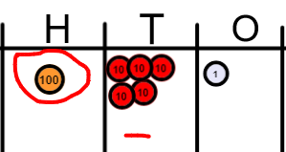  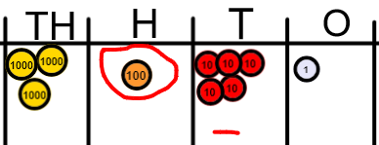 | 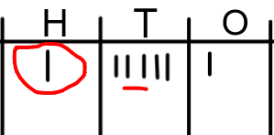  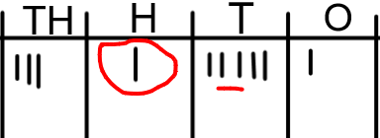 | 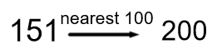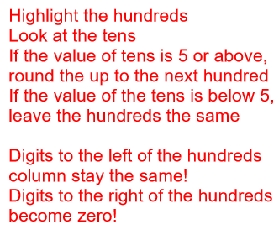
Rounding numbers to the nearest 1000 | 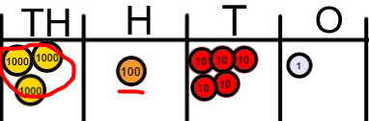  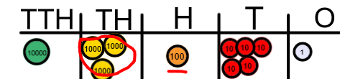 | 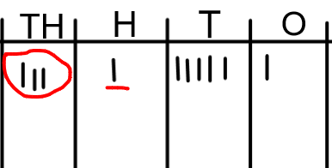  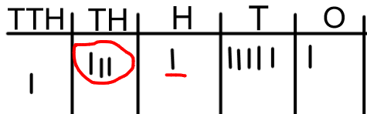 | 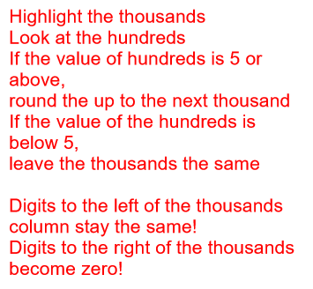  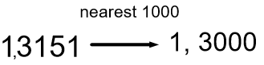  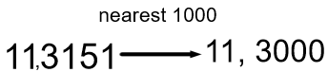
Rounding decimals to the nearest tenth (1 decimal place) | 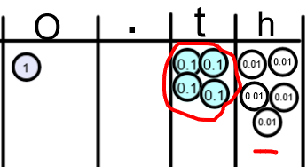 | 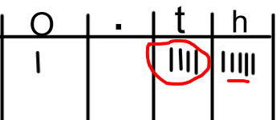 | 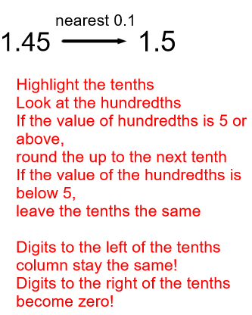

Progression in the teaching of Calculations

 | Year 1 | Year 2 | Year 3 | Year 4 | Year 5 | Year 6
Addition | Combining two parts to make a whole: part, part whole model and bar model  Add one more  Add two ones  Number bonds to 20  Solve problems (Concrete and pictorially) with missing numbers | Fluency in number bonds to 20  Related facts to 100 (e.g. 2 + 8 = 10 therefore 20 + 80 = 100) Part, part whole and bar model  Adding TO + O mentally  Adding TO + O using number line  Counting on  Adding TO + T mentally  Adding TO + T using number line  (concrete, Pictorial, Abstract)  Adding two 2 digit numbers mentally and on a number line  Begin using a column method with no re-grouping/ exchanging (Expanded/ partitioning)  Commutative law  Solve problems with inverse relationship and missing numbers | Add a 3-digit number and ones mentally  Add a 3-digit number and tens mentally  Add a 3-digit number and hundreds mentally  (Partitioning)  Column method for addition without re-grouping/ exchanging  (estimating and checking answers with the inverse)  Column method for addition with re-grouping/ exchanging ones and tens.  Solve problems including missing number problems  (Concrete, Pictorial Abstract) | Add a 4-digit number and ones mentally  Add a 4-digit number and tens mentally  Add a 4-digit number and hundreds mentally  Add a 4-digit number and thousands mentally  Column method with re-grouping/ exchanging  Use inverse operations to check  Solve multi-step problems | Add large numbers mentally  Column method with re-grouping/ exchanging  Column method with decimals (same amount of decimal places)  (Concrete, Pictorial Abstract)  Solve multi-step problems  Use rounding to check answers | Add large numbers mentally  Column method with re-grouping/exchanging.  Column method with decimals (different amounts of decimal places)  (Concrete, Pictorial Abstract)  Solve multi-step problems  Use rounding to check answers
Subtraction | Take away ones (counting back)  Find the difference  Inverse of addition number bonds  Part, part whole and bar model  Solve problems (concrete and pictorial) including missing numbers. | Develop fluency of number bonds and inverse of addition  Subtract ones from a 2-digit number mentally and counting on, on a number line  Subtract tens from a 2-digit number mentally and on a number line  Subtract two 2-digit numbers mentally and on a number line  (Concrete, Pictorial, Abstract)  Begin the column method (expanded or partitioned) with no re-grouping/ exchanging  Solve problems (Concrete, Pictorial, Abstract) including missing numbers.  Commutative law | Subtract ones from a 3-digit number mentally  Subtract tens from a 3-digit number mentally  Subtract hundreds from a 3-digit number mentally  (Concrete, Pictorial, Abstract)  Column Subtraction without re-grouping/ exchanging  Solve problems (Concrete, Pictorial and abstract) involving missing numbers.  Use the inverse to check answers | Subtract ones from a 4-digit number mentally  Subtract tens from a 4-digit number mentally  Subtract hundreds from a 4-digit number mentally  Subtract thousands from a 4-digit number mentally  (Concrete, Pictorial, Abstract)  Column Subtraction with re-grouping/ exchanging  Use inverse operations to check answers  Solve problems (Concrete, Pictorial and abstract) involving missing numbers. | Subtract large numbers mentally  Column method for subtraction with re-grouping/exchanging  Column method with decimals (Same amount of decimal places)  (Concrete, Pictorial, Abstract)  Solve multi-step problems  Use rounding to check answers. | Subtract large numbers mentally  Column method for subtraction with re-grouping/exchanging  Column method with decimals (different amount of decimal places)  (Concrete, Pictorial, Abstract)  Solve multi-step problems  Use rounding to check answers.
Multiplication | Doubling (CPA)  Counting in multiples  Arrays (with support)  Use CPA and Arrays with support to solve problems | Doubling (CPA)  Counting in multiples (2,5,10)  Repeated addition  Arrays  Commutative law  Solve problems using arrays and repeated addition | Consolidate counting in 2,5, 10  Counting in multiples (3,4,8)  Repeated addition (CPA)  Arrays(CPA)  Commutative law  Use known number facts and partitioning to multiply 2-digit by 1 digit numbers mentally  Progress to written grid and column method (expanded or partitioned)  Solve problems inc where n objects are connected to m objects (CPA) | Rapid recall of multiplication facts up to 12 x 12  Use known number facts to multiply mentally inc. x 0, x1 and multiplying 3 numbers  Recognise and use factor pairs  Column (or grid) multiplication  2 and 3 digit multiplied by 1 digit) (CPA)  Solve problems inc. distributive law and where n objects are connected to m objects (CPA) | Consolidate rapid recall of facts  Multiply mentally using known facts  Column multiplication (up to 4 digit numbers by 1 or 2-digit numbers)  (CPA)  Multiply decimals using column method  Identify multiples and factors  Identify prime numbers  Solve problems inc factors, multiple, squares and cubes (CPA) | Multiply mentally using known facts  Column method (4-digit by 2- digit numbers)  Solve multi-step problems inc. common factors, common multiples, and prime numbers  (CPA)
Division | Sharing objects into groups (CPA)  Solve one step problems using concrete materials with support | Relate division to multiplication facts (2, 5, 10)  Divide mentally using inverse multiplication facts  Division as grouping  Use arrays (CPA)  Use a number line (CPA)  Solve problems using arrays, repeated addition and mental methods (CPA) | Recall division facts for 3,4,8 times tables  Divide mentally using known facts inc. 2-digit by 1-digit number.  Divide 2-digit by 1-digit numbers using arrays (grouping) (CPA)progressing to the written short division method (CPA)  Solve problems inc. missing numbers and where n objects are connected to m objects. | Rapid recall of division facts for up to 12 x table  Division using known facts mentally  Division with arrays with remainders  Short division up to 3-digit by 1-digit (CPA)  Solve problems inc missing numbers (CPA) | Divide numbers mentally using known facts  Short division up to 4-digit by 1 digit number interpreting remainders appropriately for the context (CPA) | Short division  Long division up to 4-digit by 2-digit numbers interpreting remainders as whole numbers, fractions or round (CPA)  Dividing a decimal by a whole number

Progression in the teaching of Calculations
Add it!

Objective | Concrete  BUILD IT/USE IT! | Pictorial  DRAW IT! | Abstract  SOLVE IT!
Counting objects and adding one | 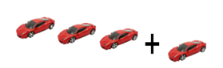  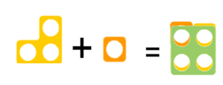 | 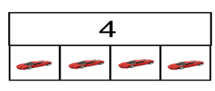 | 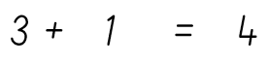
Adding two ones | 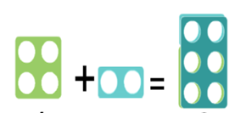 | 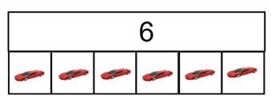
Using a number line to count on | 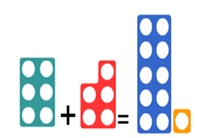 | 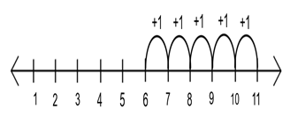  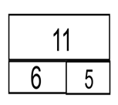 | 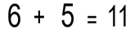
Adding tens and ones on a number line |  | 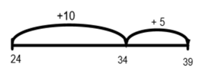  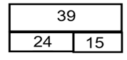 | 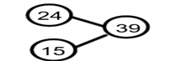  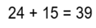
Adding two 2-digit numbers without re-grouping/ exchanging | 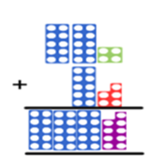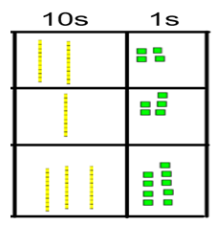 | H T O  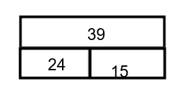 | 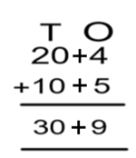
Partitioning method when crossing ten (not re-grouping or exchanging) | 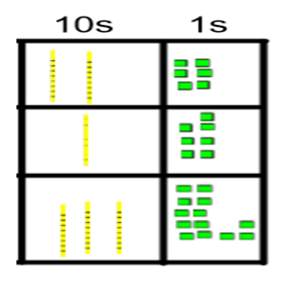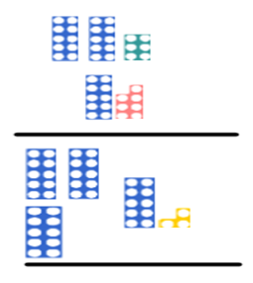 | 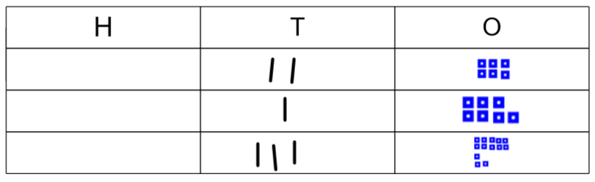 | 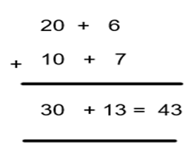
Adding using the column method without re-grouping/exchanging | 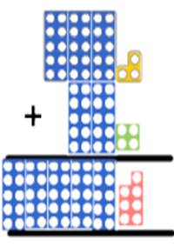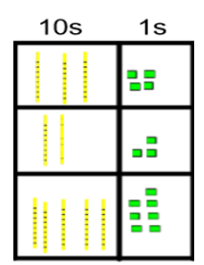 | 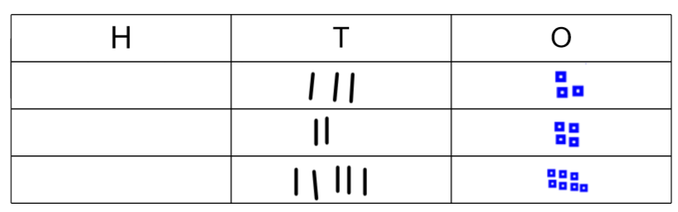  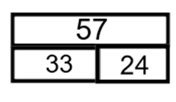 | 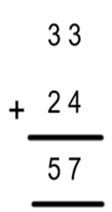
3 digit column method without re-grouping/ exchanging | 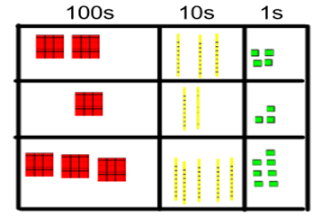 | 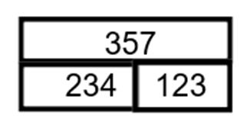  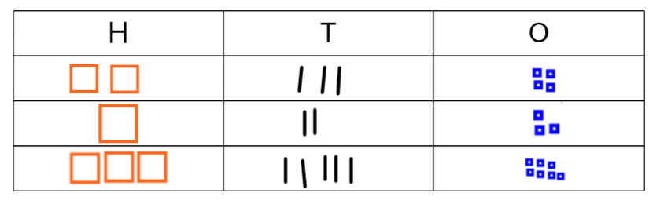 | 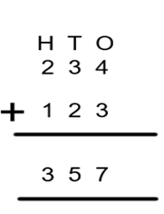
Column addition with re-grouping/ exchanging | 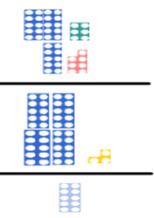  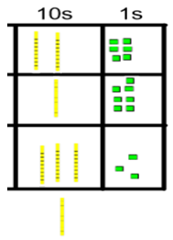  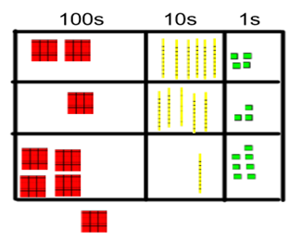 | 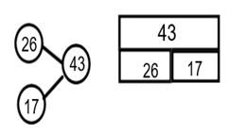  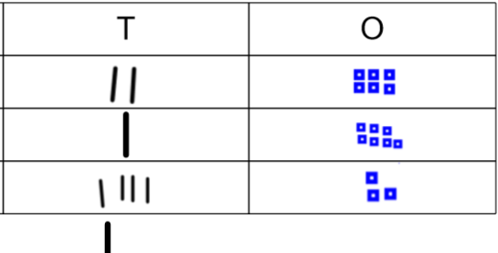  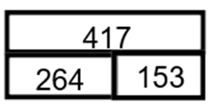 | 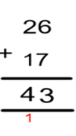  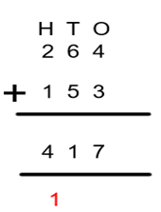
Column addition re-grouping/ exchanging ones and tens together | 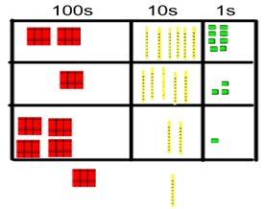 | 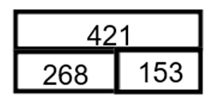 | 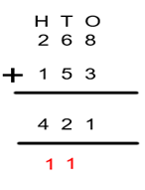
Applying the column method to larger numbers and adding decimals | 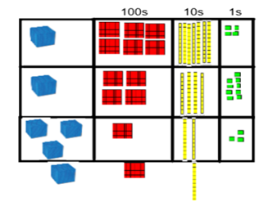  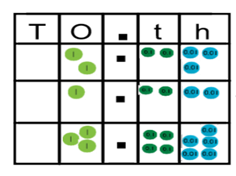 | 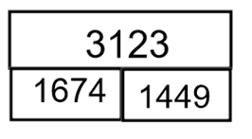 | 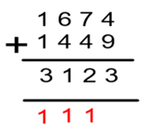  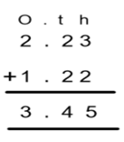
Progression in the teaching of Calculations
SUBTRACT IT!

Objective | Concrete  BUILD IT/ USE IT! | Pictorial  DRAW IT! | Abstract  SOLVE IT!
Taking away ones | 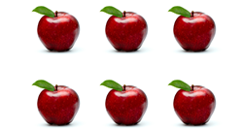 | 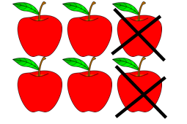  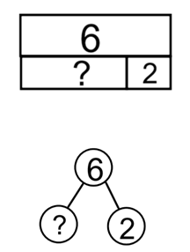 | 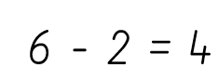
Find the difference between two numbers | 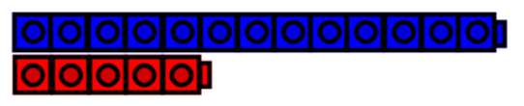 | 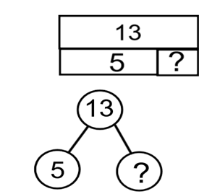 | 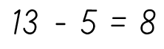
Use a number line to find the difference |  | 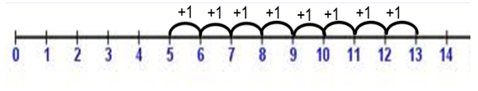
Using number bonds to 10 to make more efficient jumps on a number line | 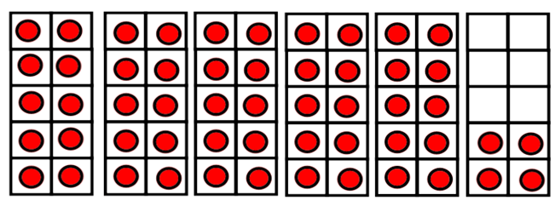 | 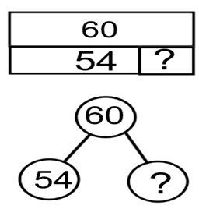  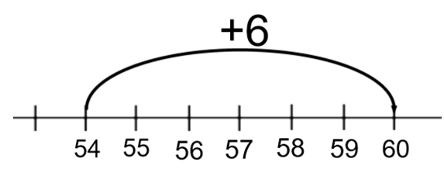 | 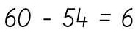
Jumping in tens and ones efficiently on a number line |  | 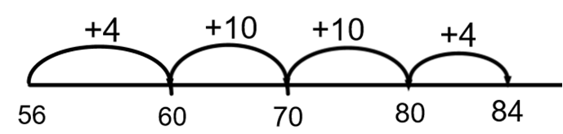  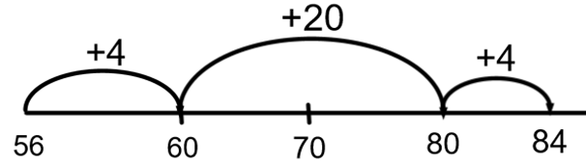 | 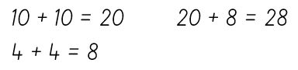  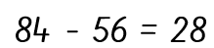
Progressing towards written column method – partitioning and without re-grouping/exhcanging | 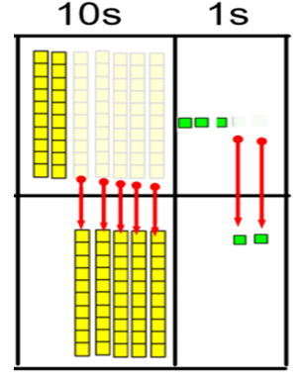 | 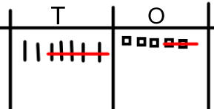 | 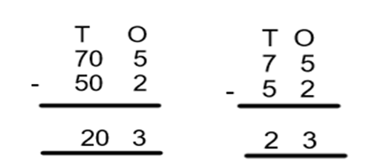
Subtracting using the column method up to 3 digit numbers without exchanging | 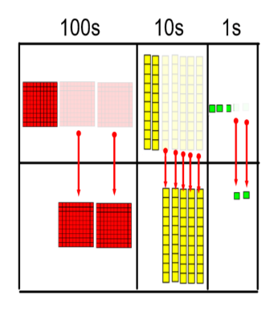 | 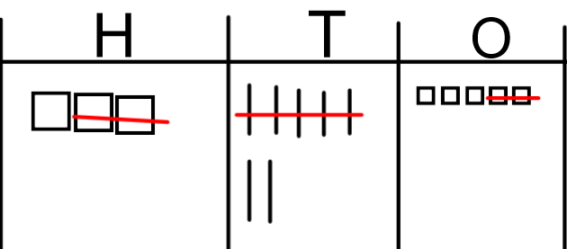 | 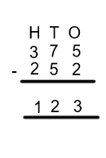
Column method with re-grouping/ exchanging | 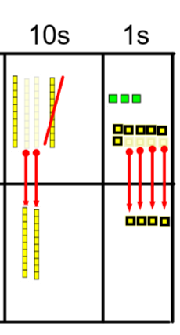 | 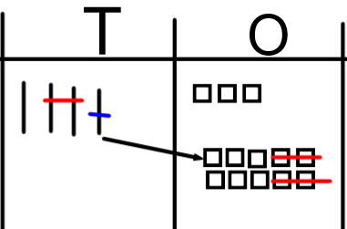 | 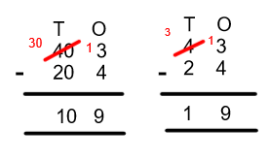
 | 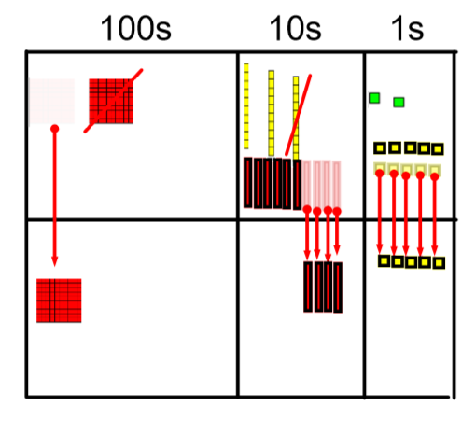 |  | 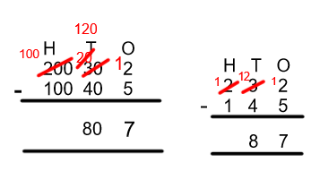

Progression in the teaching of Calculations
Multiply it!

Objective | Concrete  BUILD IT/USE IT! | Pictorial  DRAW IT! | Abstract  SOLVE IT!
Grouping in 2s,5s and 10s | 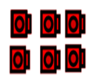 | 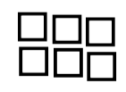 | 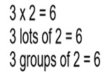
Counting in 2s, 5s and 10s | 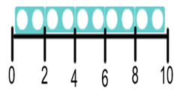  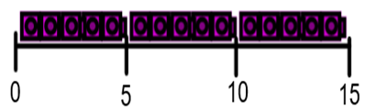 | 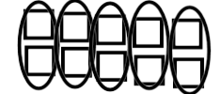  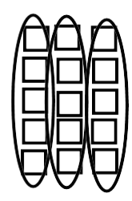 | 0,2, 4, 6, 8, 10…  …10, 8, 6, 4, 2,0  0,5,10,15…  …15,10,5,0
Using repeated addition | 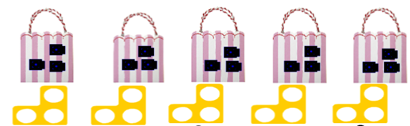 | 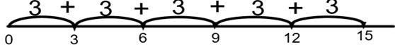  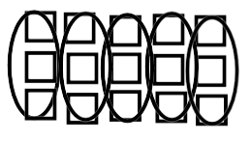 | 5 x 3 = 15
Using arrays and commutative law | 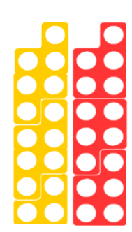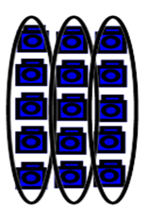  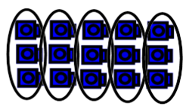 | 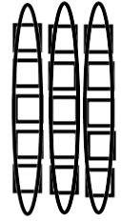  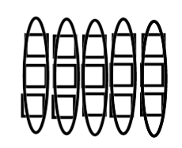 | 3 x 5 = 15  5 x 3 = 15
Deriving associated division facts with arrays | 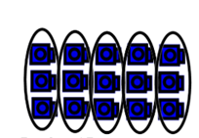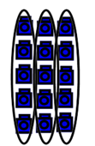 |  | 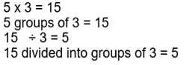  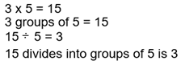
Multiplying by ten | 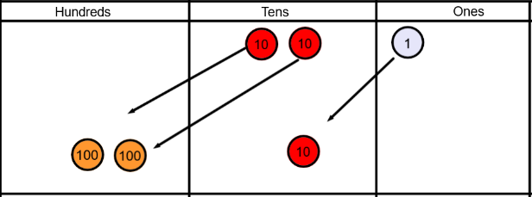 | 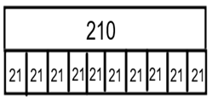  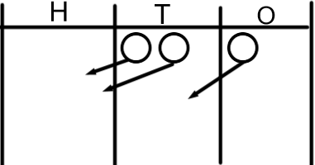 | 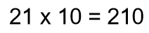
Multiplying by 100 | 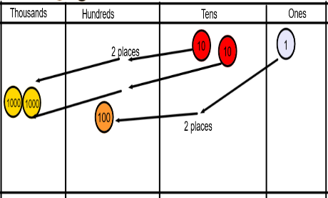 | 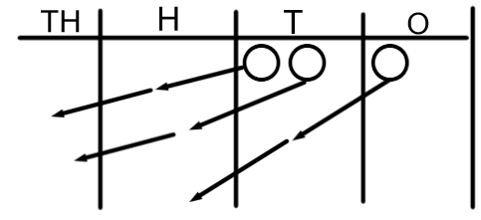 | 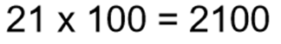
Partitioning and grid method | 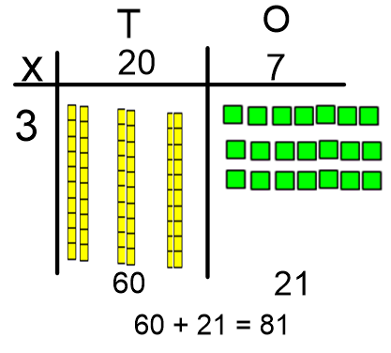 | 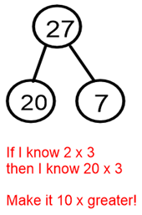  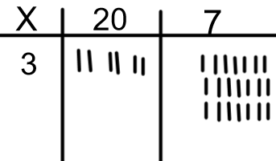 | 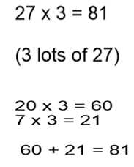
Multiplying 2 digit by 2 digit numbers | Use dienes as above | 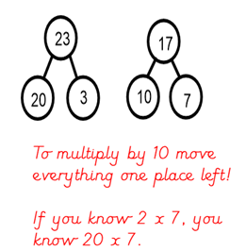  Draw the dienes as above | 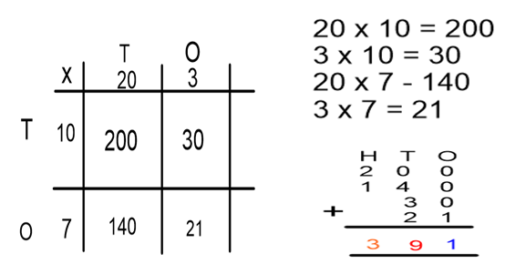
Multiplying 3 digit by 2 digit numbers – grid method |  | 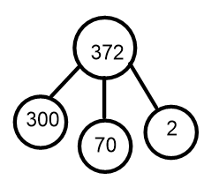  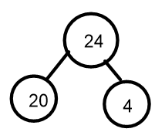 | 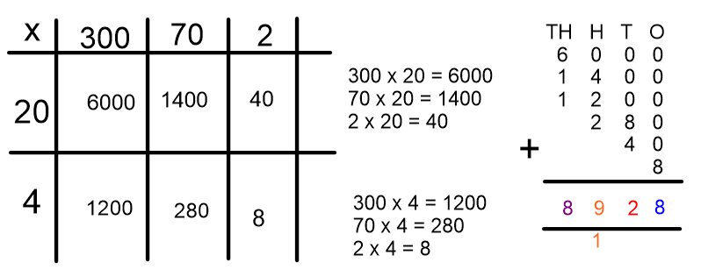
Efficient written column method | 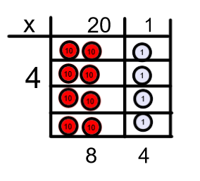 | 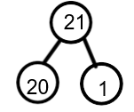  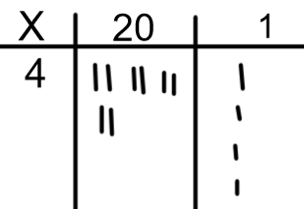 | 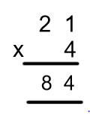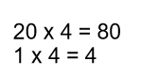
Efficient column method with re-grouping/ exchanging | 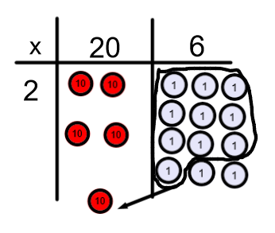  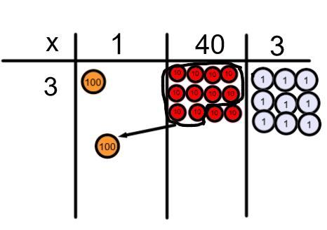 | 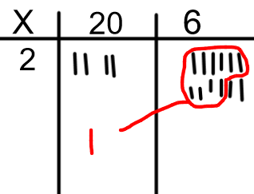  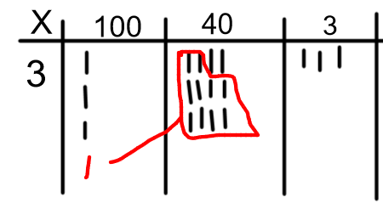 | 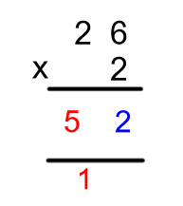  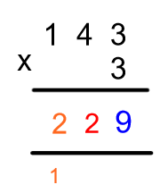
Efficient column method 2-digit by 2- digit | 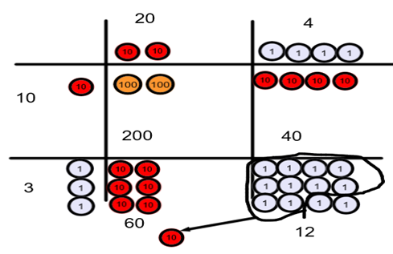 | Draw the dienes/ place value coutners as above | 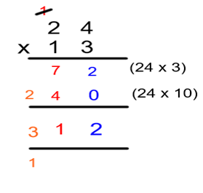
Efficient column method for multiplying decimals |  | 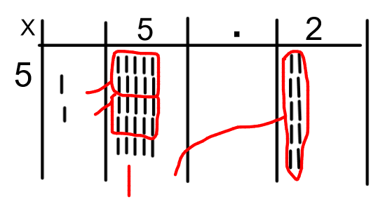 | 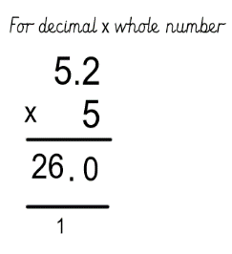  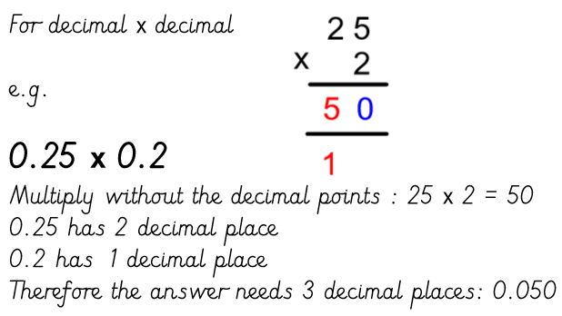

Progression in the teaching of Calculations
Divide it!

Objective | Concrete  BUILD IT/USE IT! | Pictorial  DRAW IT! | Abstract  SOLVE IT!
Sharing objects (2, 5, 10) | 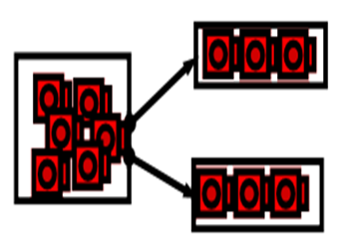 | 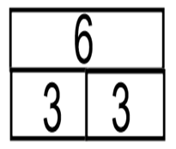  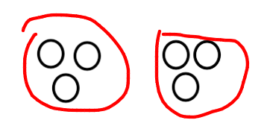 | 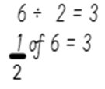
Division as grouping (2,5,10) | 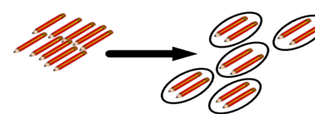 | 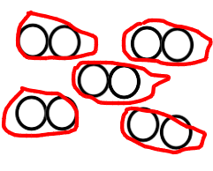  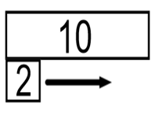 | 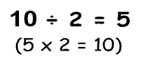
Using a number line for grouping | 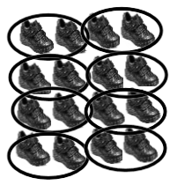 | 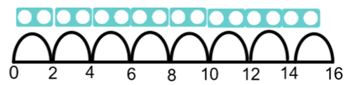  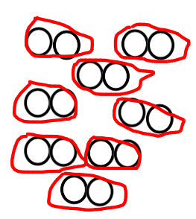 | 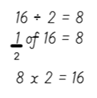
Commutative law with arrays | 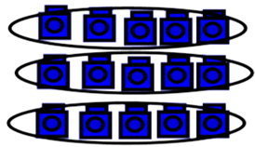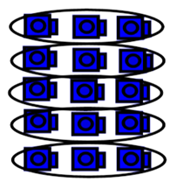 | 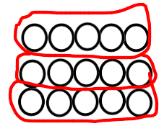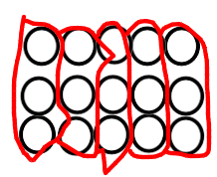 | 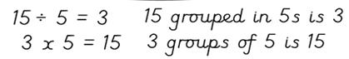  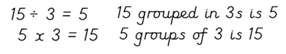
Division with remainders (Sharing) | 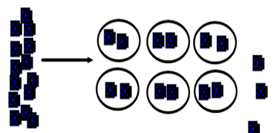 | 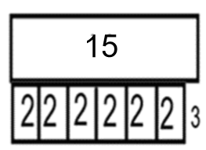  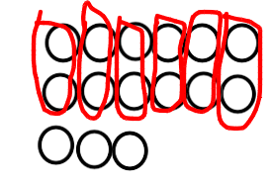 | 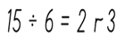
Division with remainders (grouping) | 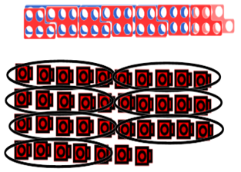 | 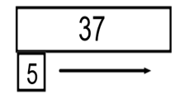  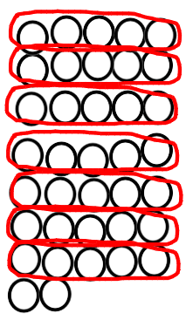 | 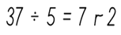
Dividing by 10 | 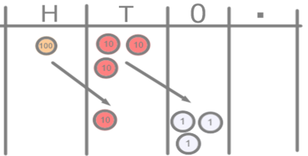 | 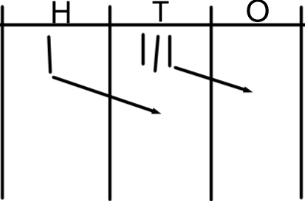 | 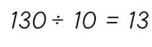
Dividing by 100 | 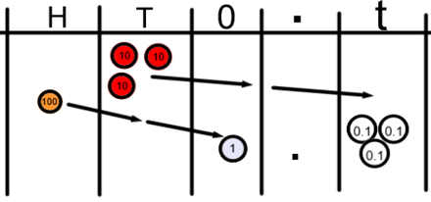 | 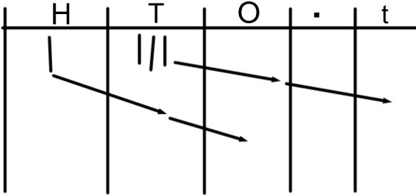 | 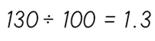
Short division (no remainders) | 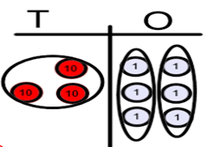 | 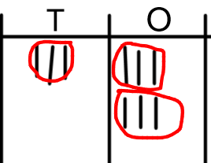 | 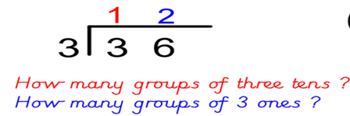
Short division with re-grouping/exchanging | 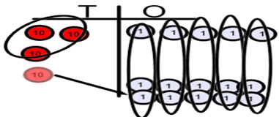 | 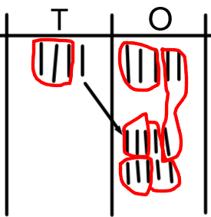 | 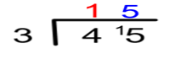
Short division with re-grouping/exchanging | 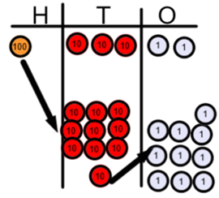 | 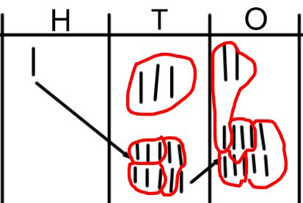 | 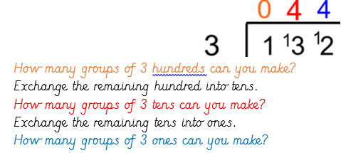
Short division with remainders | 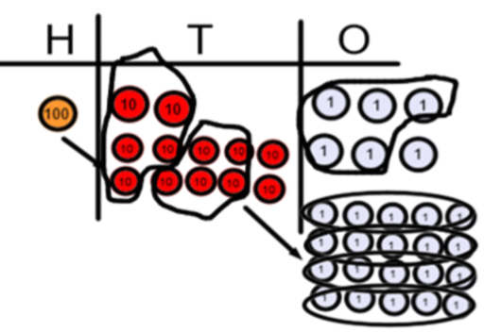 | 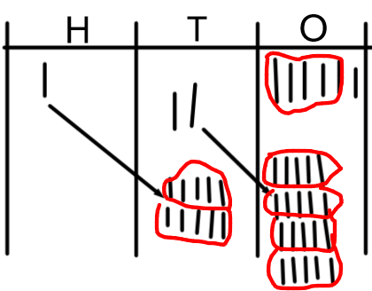 | 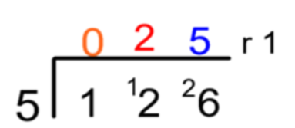  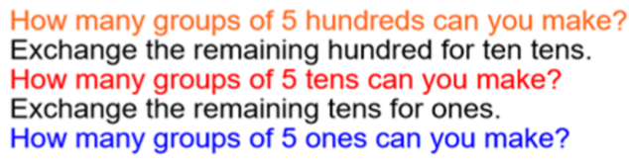
Dividing decimals | 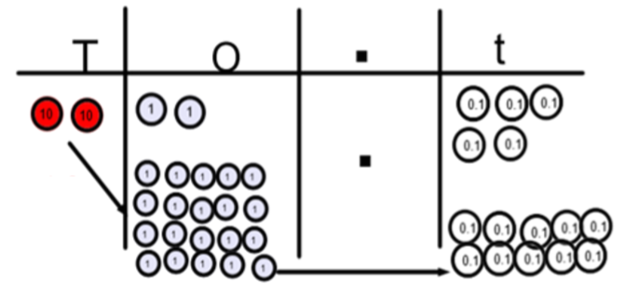 |  | 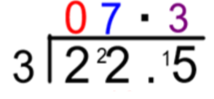  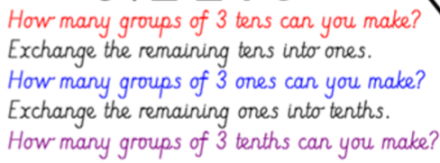
Expressing remainders as fractions | 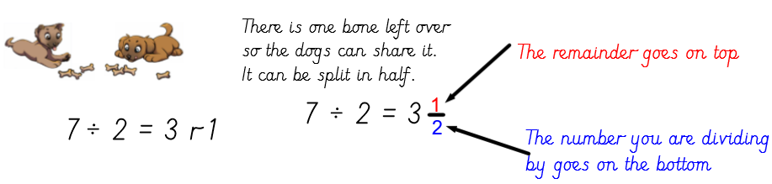

Progression in teaching Fractions

Objective | Concrete  BUILD IT/ USE IT! | Pictorial  DRAW IT! | Abstract  SOLVE IT!
Finding half of a shape | 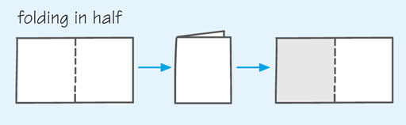 | 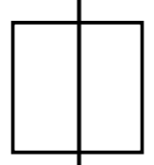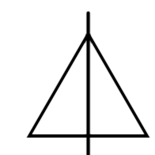 | 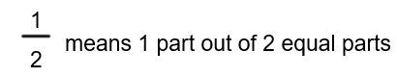
Finding a quarter of a shape | 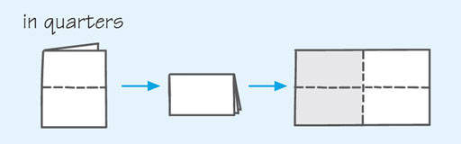 | 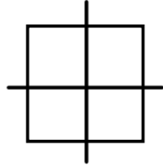 | 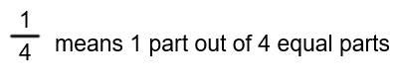
Finding half by grouping in 2s (not sharing into 2 groups)  Knowing half of even numbers to 20 | 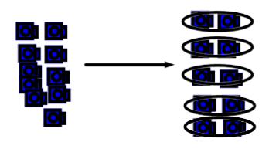 | 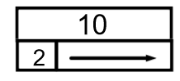 | 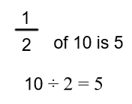
Finding a quarter by grouping in 4s (not sharing into 4 groups) |  | 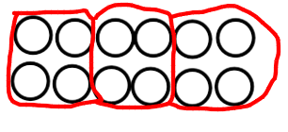  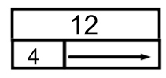 | 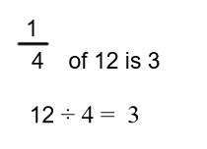
Using multiplication and division facts to find fractions of a number |  | 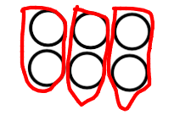  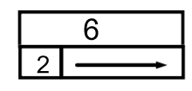 | 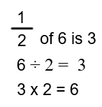
Finding other fractions of shapes |  |  | 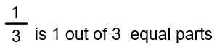
Finding non-unit fractions of a number using sharing (understanding numerator and denominator) | 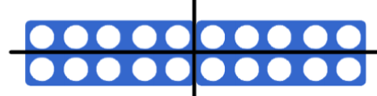 | 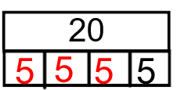  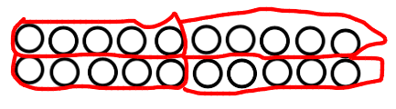 | 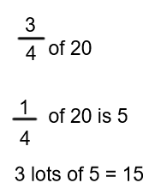
Use known number facts to find unit and non-unit fractions of amounts |  |  | 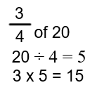
Recognise simple equivalent fractions | 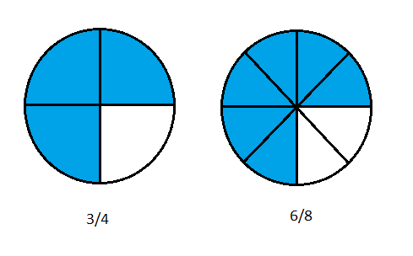  (Fraction pieces) | 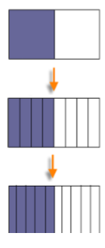 (Bar model) | 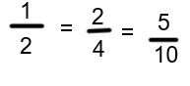
Compare and order fractions with the same denominator | 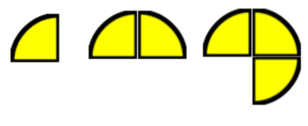  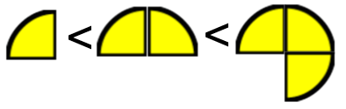 | 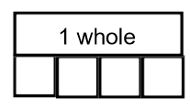 | 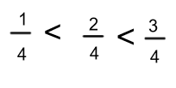
Compare and order unit fractions |  | 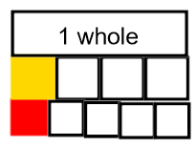 | 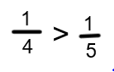
Recognising decimal equivalence for fractions – tenth and hundredths | 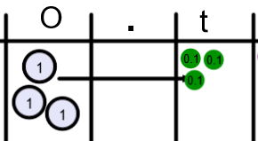 | 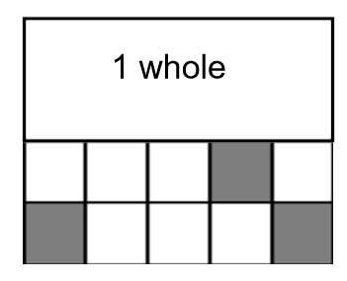  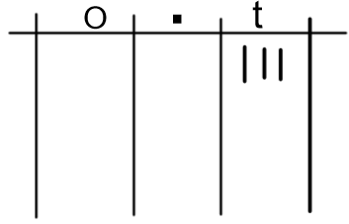  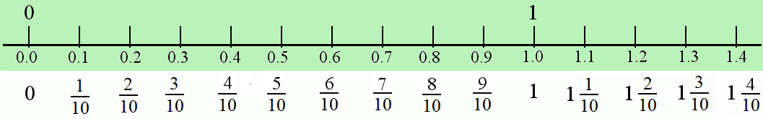 | 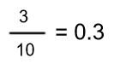
Recognise decimal equivalence for fractions – half, quarter, three quarters, one fifth | 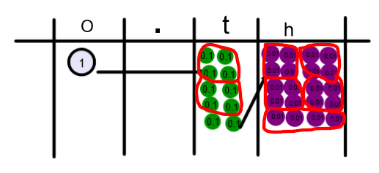 | 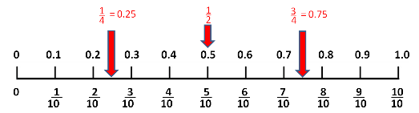  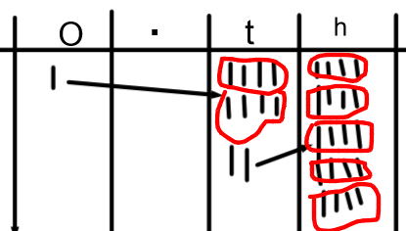 | 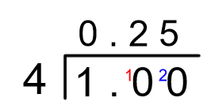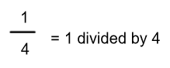  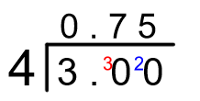  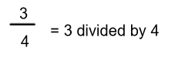
Adding fractions with the same denominator |  | 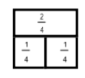 | 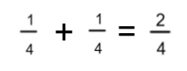
Adding fractions with different denominators |  | 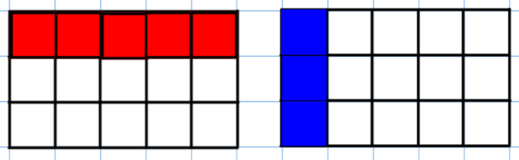  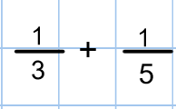 | 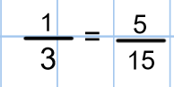  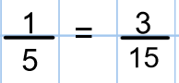  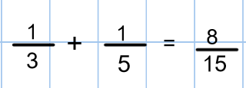
Subtracting fractions with the same denominator |  | 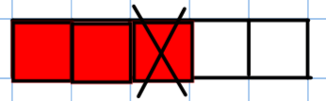 | 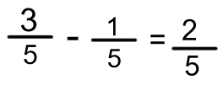
Subtracting fractions with different denominators |  | 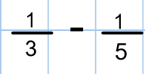  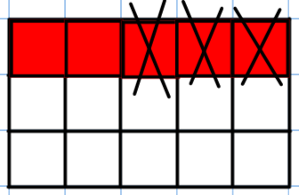 | 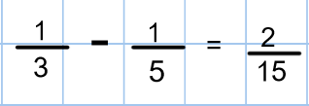
Multiplying fractions |  | 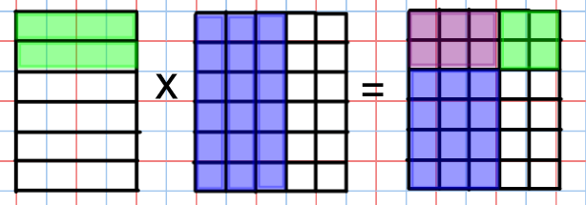 | 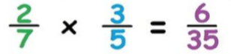  Multiply the numerators and multiply the denominators!
Dividing fractions by a whole number |  | 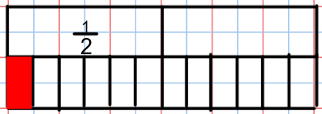  Draw the first fraction as a bar model.  Divide all parts of the bar model into equal parts determined by the whole number.  Determine your answer by determining the size of each piece. | 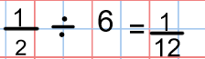  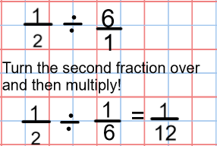
Dividing a fraction by a fraction |  | 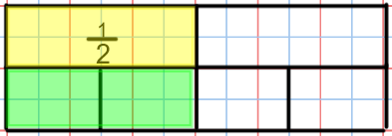  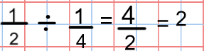  Draw the first fraction in a bar model.  Divide the whole bar into equal parts determined by the second fraction.  How many of the second fraction parts are equal to the first fraction? | 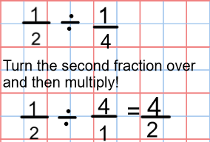

Reviewed and Approved by:- Liz Lawley

Date of meeting:- 19.5.20

Signature:- Mr C Tolson

Date:-

Next review date:- 19/05/21

