Our new unit is Creation/Fall.
What can you identify in the image below? Label images, words, colours you notice and why you think they are important.

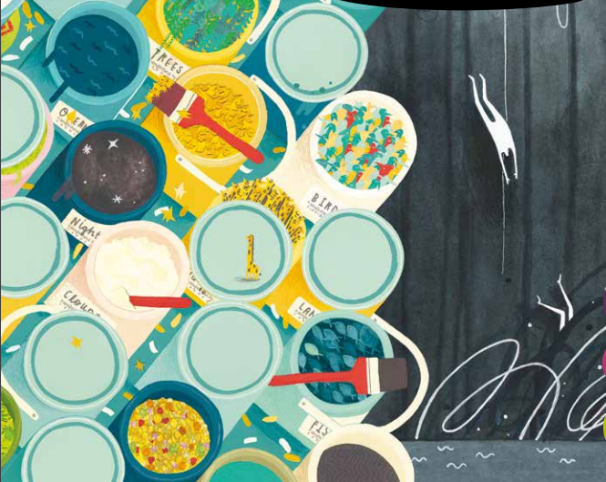

-------------------------------------------------------------------------------------------------------------------------------------------------
We are going to be looking at the key question -
What do Christians learn from the Creation story?
Speed write! Note down what you think.

Now, listen to ‘Wonderful World’ by Louis Armstrong. How does it make you feel?
https://www.youtube.com/watch?v=CWzrABouyeE
-------------------------------------------------------------------------
Nature is full of ‘wow factors’, which Christians believe were created as gifts from God.

Next time you can go for a walk or explore your garden, try to fill a colour chart like the one above. Can you find all of the colours of the rainbow, or different shades of a particular colour without destroying any living plants?

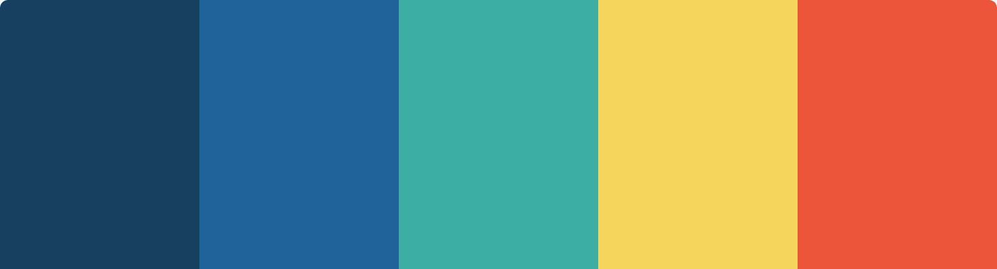

Close your eyes and listen to ‘nature’s symphony’ — can you hear bees, birds, leaves rustling? What else can you hear?

