Monday 29th June
RE – What would make our community a more respectful place?

In 2001, British Asian and white youths fought and businesses, shops and cars were targeted with violence. Hundreds of people were arrested or injured. Why did happen and wat has happened since?
It all started on the nights of 8th and 9th July 2001 when groups of between 30 and 100 white youths attacked police and Asian-owned businesses in the Ravenscliffe and Holmewood areas. What began as a riot, turned into an ethnic –related disturbance. A notable point of the rioting was the firebombing of Manningham Labour Club, which was a recreational centre.
Ten years later, the BBC published an article which stated that there was still a divide in Bradford and that Segregation still very much existed.
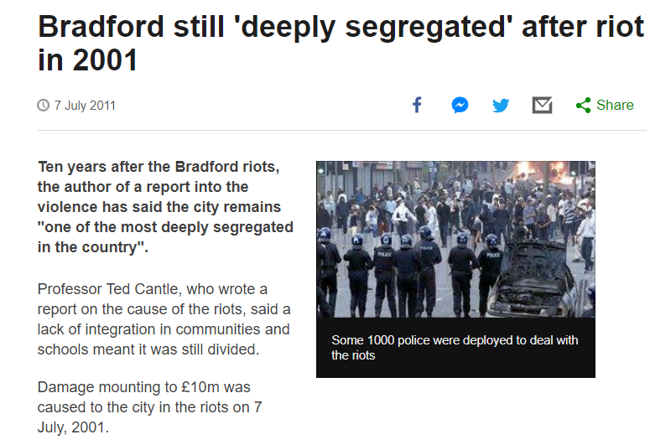

Today, in Bradford there are groups of people from different faiths, bringing together the community and encouraging interfaith events.
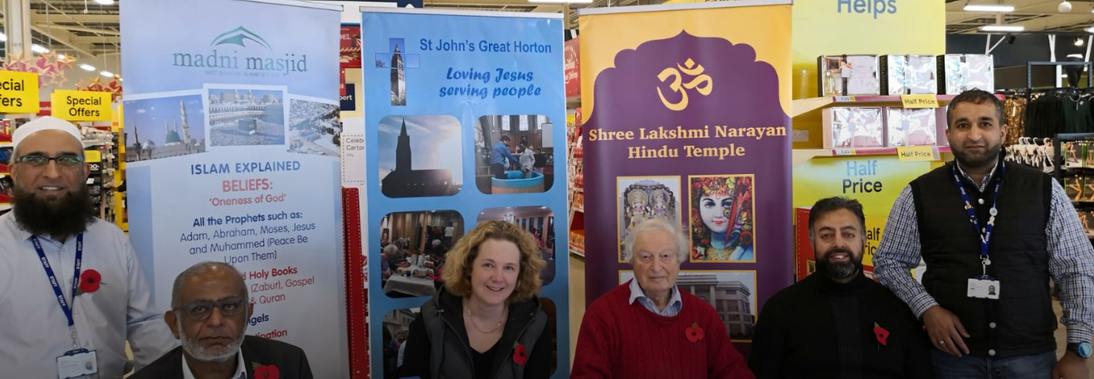
Interfaith weeks take place all over Bradford to represent the diversity. Bradford faith groups have come together to show unity in Tescos, wearing their faith costumes and handing out sweets, chocolates and leaflets on the significance behind it.
Interfaith walks and trips are arranged to generate an idea of solidarity and to celebrate diversity in the heart of Bradford.
What else does Bradford have to offer to bring the people of different faiths together?
What does our school offer to the community to bring people of different faiths together?
What else could we offer at school to bring the community together and to celebrate diversity at our school?
Your task
Think of an event that you would like to see in our community that would do this and create a leaflet to advertise it.
Make sure you state why this event would be a good idea and what it hopes to achieve.
Hopefully, we can use your event ideas and hold the event at school when it is safe to do so next year.
