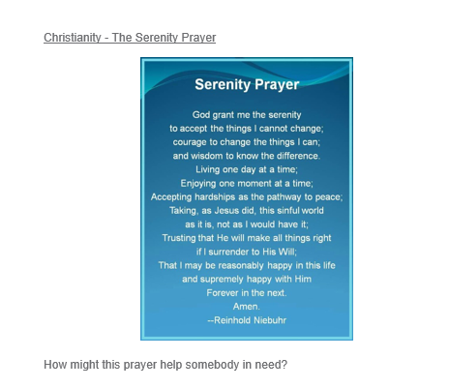
______________________________________________________________________________________________________________________________________________________________________________________________________________________________________________________________________________________________________________________________________________________________________________________________________________________________________________________________________________________________________________________________________________________________________________________________

Now can you create a prayer for yourself? You could make a 3D photograph to place it in.

