Science
Thursday 18th June 2020
What is thermal conductivity?
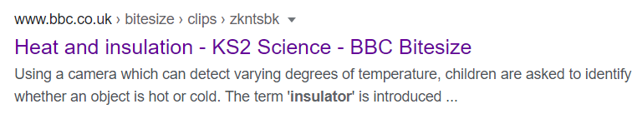
Watch the following clip on BBC Bitesize – Heat and Insulation

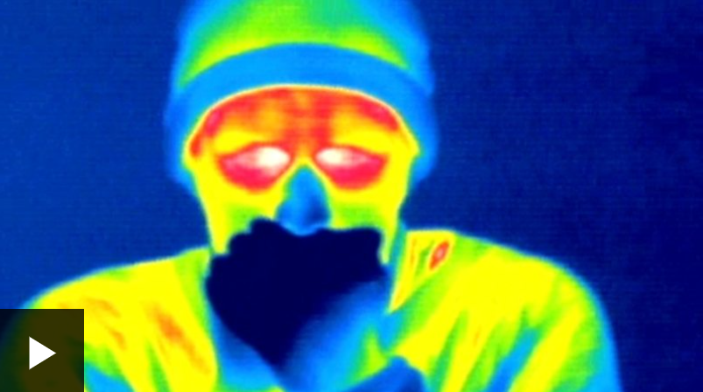

https://www.bbc.co.uk/bitesize/clips/zkntsbk
You can also complete the quiz about which materials make good thermal conductors and insulators. Read the information at the top of the page before you start.

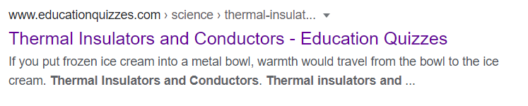

https://www.educationquizzes.com/ks2/science/thermal-insulators-and-conductors/

Exploration!
Set up an experiment of your own to test thermal conductivity/insulation. A good one to try is to wrap mugs in different materials e.g. cotton wool, aluminium, paper and fill each one with hot water (an adult needs to do this with you, be careful).

If you have a thermometer, you can read the temperature for each mug at the start and take readings every couple of minutes and record in a table. You can then see which material is the best/worst insulator!

If you don’t have a thermometer, you could do the same experiment but only use lukewarm water. Use your little finger to test which liquid is cooling the quickest. Alternatively, there are apps that you can download to show thermal images of the mug (just like in the video clip). You can take pictures of the mugs at different points to show the change in temperature.

