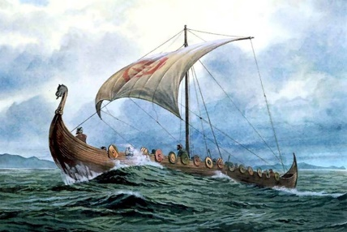
Science
Thursday 25th June 2020

How did Vikings clean dirty water?
So far, we have looked at a range of different techniques to separate materials. See if you can remember what each of the following are. If you are struggling then research to help you – BBC Bitesize can be a big help.
Evaporation
Filtering
Dissolving
Sieving

Do you think Vikings used the same techniques we do? How do you think they cleaned dirty water to make it drinkable?
You are going to test it out!
Mix together water, sticks, soil and salt in a cup. Use different separation techniques to get the water as clear as possible.
Use what you learnt at the Solenis Science Lab to help you.
- What materials in your house could you use as a filter?
- Which method will you separate the larger solids from the smaller solids?
- How will you remove the salt?

Take a before and after picture to show how clean you get your water!

**Do not drink the water, it will not be totally clean – remember, we need chemicals for this!**

