L.I:- To be able to explain how to prevent illness and present information in different ways.
Vaccines
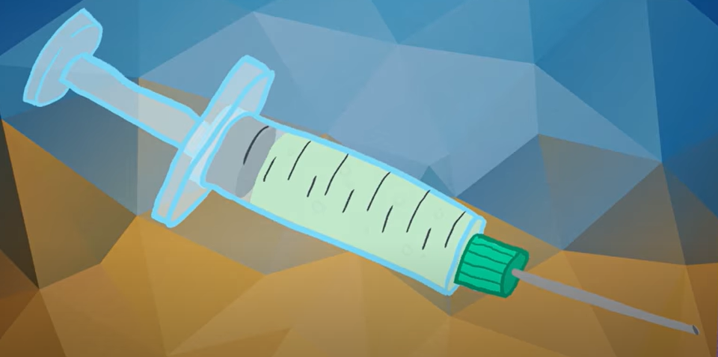
- If microorganisms, like viruses get into our bloodstream and we don’t have the correct white blood cells to fight it, we can become very poorly.
- This is when we need a vaccine or as we call them, injections.

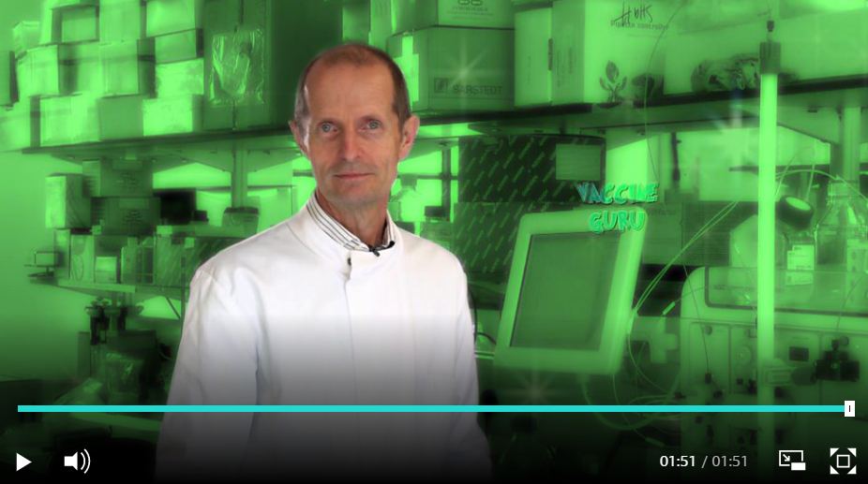
- https://www.youtube.com/watch?v=5SproXmRUkI
- Chemists/pharmacists are responsible for creating new materials that are used within medicines to be used in vaccines.
- However, they are currently finding it difficult to create materials that treat the symptoms of Coronavirus. The coronavirus is spreading around the world, and it has been declared a global emergency by the World Health Organization.

https://www.bbc.co.uk/newsround/51312911

Can you create a leaflet to explain the benefits of vaccines and the difficulties we face due to Coronavirus. Look at the power point for more information.

