Date:______________________
Content Domains: 2b/2d/2g
Pages 18-23
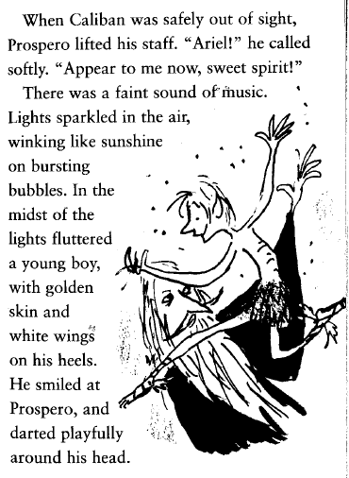
How is Ariel made to appeal to the reader?
Use the text to support your answer.
_______________________________________
_______________________________________
_______________________________________
_______________________________________
_______________________________________
_______________________________________
_______________________________________
_______________________________________
_______________________________________
_______________________________________
_______________________________________
_______________________________________
_______________________________________

Using pages 21 and 22. Describe what happened to Prospero.
_________________________________________________________________________________________________________________________________________________________________________________________________________________________________________________________________________________________________________________________________________________________________________________________________________________________________________________________________________________________________________________________________________________________________________________________________________________________________
How does the reader know that Prospero isn’t after revenge?
_______________________________________________________________________________________
What does Ariel hope will happen at the end?
_______________________________________________________________________________________
_______________________________________________________________________________________

