Today, we are going to start to read Chapter 4 – The Keeper of the Keys
Questions for pages 57-59
Can you write your own 5 questions for your peers to answer?

On page 57, the paragraph beginning ‘Knew! Shrieked Aunt Petunia suddenly…’
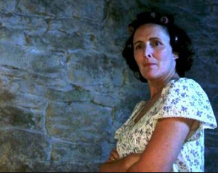
Can you act out how Aunt Petunia would say her speech? Can you explain why you have acted it that way? Would be she bitter? Kind? Scornful?

