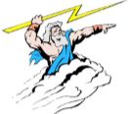 | Zeus | The most powerful god. He sends thunderbolts to earth to keep the people in order.
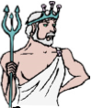 | Poseidon | He is Zeus’ brother and god of the sea. Seamen revered him.
 | Hades | He is the brother of Zeus. God of the underworld and has a 3 headed dog called Cerberus.
 | Aphrodite | The goddess of love and beauty. She was born from the sea foam.
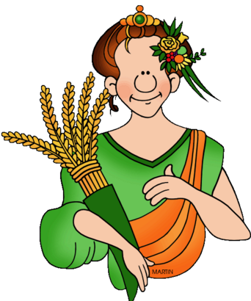 | Hestia | Hera’s sister and the goddess of marriage and domestic life.
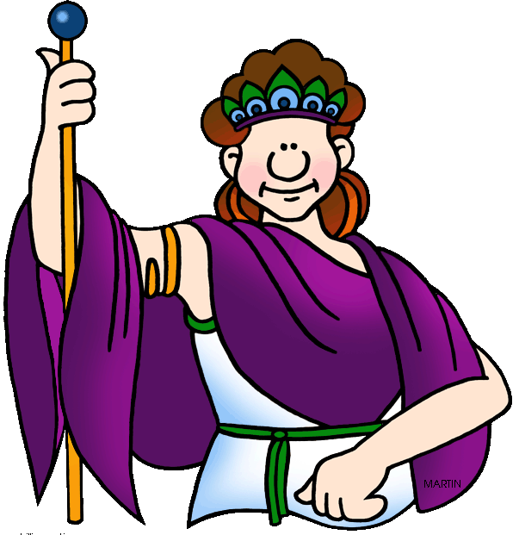 | Hera | Zeus’ wife and queen of the gods. She was known for being angry and jealous.
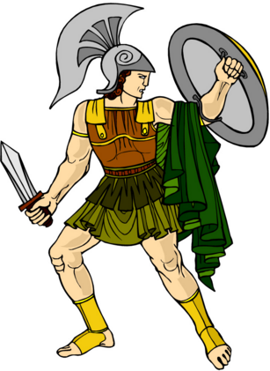 | Ares | Zeus’ son and the god of war. He hated pain and could be cruel and heartless.
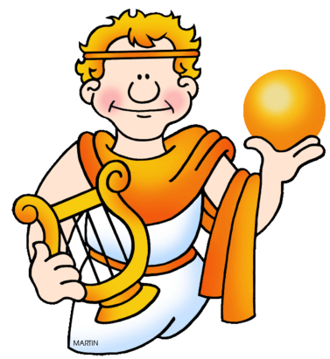 | Apollo | Zeus’ son and the god of music, the sun and light. He is Artemis’ twin.
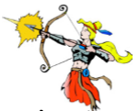 | Artemis | The goddess of the hunt. She was cold and heartless and loved no one but her family.
 | Athena | The goddess of knowledge. She was born from Zeus’ brain and Athens was named after her.
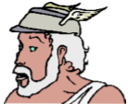 | Hermes | He was a mischievous god. He was the messenger god and was very fast.
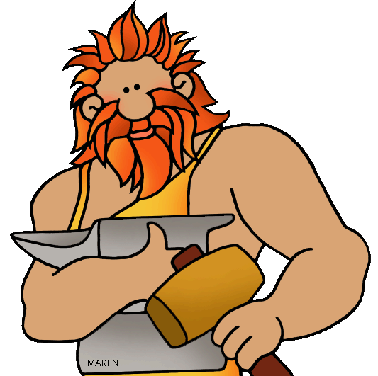 | Hephaestus | The son of Zeus and Hera, he was the god of crafts and fire, especially the blacksmith’s fire. He was the only god with a limp.

