Thursday 18th June
Revision – Subtraction fractions Reasoning Problems.

You have done a brilliant job of subtracting fractions already this week. These problems are all about subtracting fractions, but you need to explain how you got the answers.
E.g.
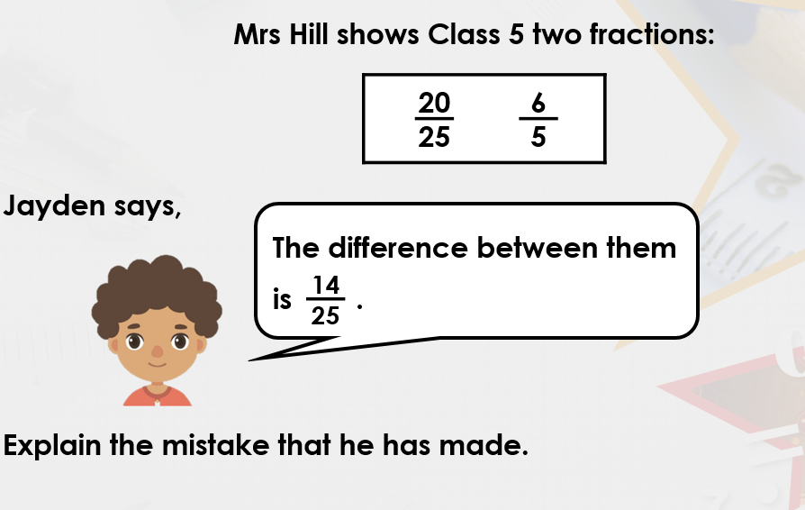
To start with, we need to make the denominators the same. 25 is a multiple of 5, so we can convert the fractions into 25ths.
$$\frac{6}{5}=\frac{30}{25}$$
$$\frac{30}{25}-\frac{20}{25}=\frac{10}{25}$$
This can be simplified by dividing the numerator and denominator by 5.
$\frac{10}{25}=\frac{2}{5}$
Jayden has left the denominator as 25, but has just subtracted the numerators as they are. He has done 20 – 6.
Click here for a video explanation!
https://www.loom.com/share/3a5bfd16eb5b43dbbef87bac80bf314a

Your Turn
