Thursday 21st June
Direct/ Indirect Speech
Now that you have had a go at punctuating direct speech and converting direct speech into indirect/ reported speech, we are going to consolidate our understanding of this and do some more work on speech.
We will apply reasoning and problem solving to direct and indirect speech.
Examples:
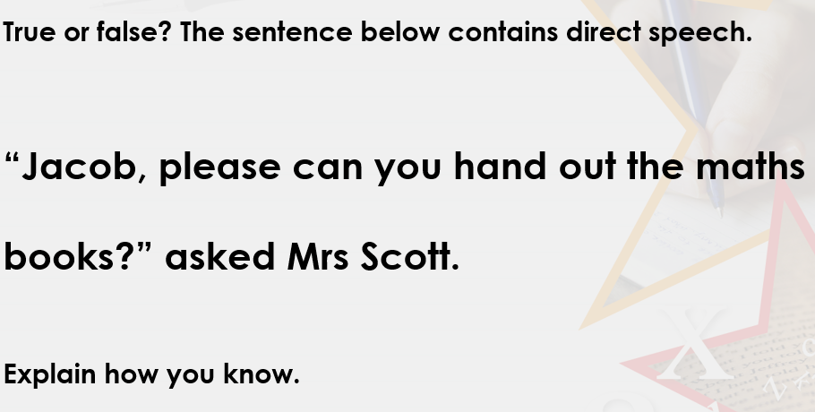
I know that this is direct speech because it has the punctuation for direct speech and the words that Mrs Scott said are repeated fully and exactly.
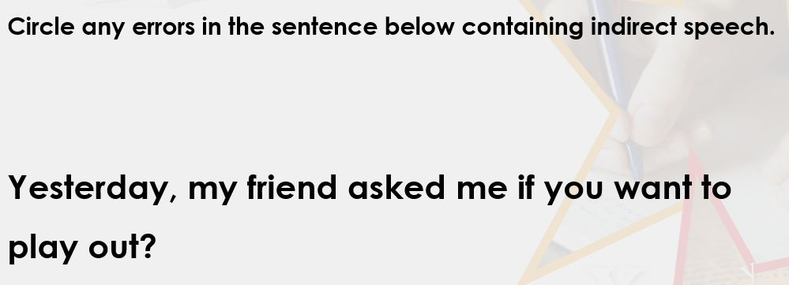
The person and the verb tense are incorrect. It should say:
Yesterday, My friend asked me if I wanted to play out.
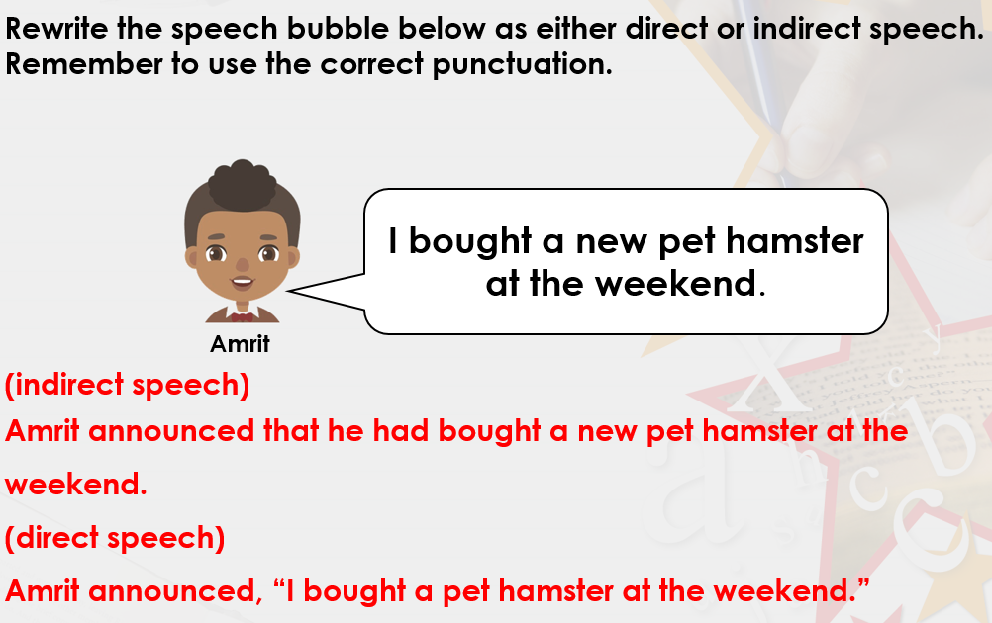

Your Turn – Have a go at these questions. Explain your answers fully.
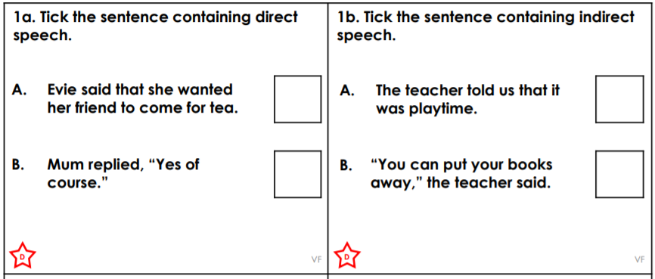
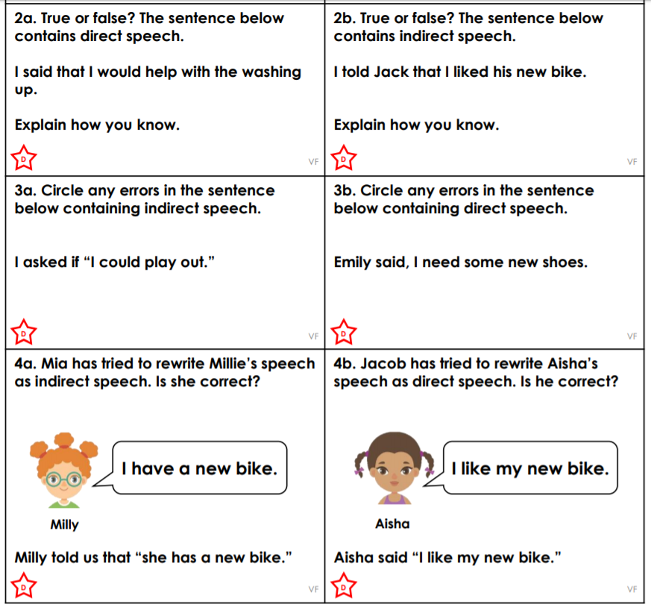

Challenge
