Thursday 25th June
Adding mixed numbers – reasoning and problem solving
You have been doing amazingly well this week with adding mixed numbers in different contexts.
Have a go at these to consolidate your learning for this week
If you are stuck, contact the Y5 team on dojo or classroom for support.
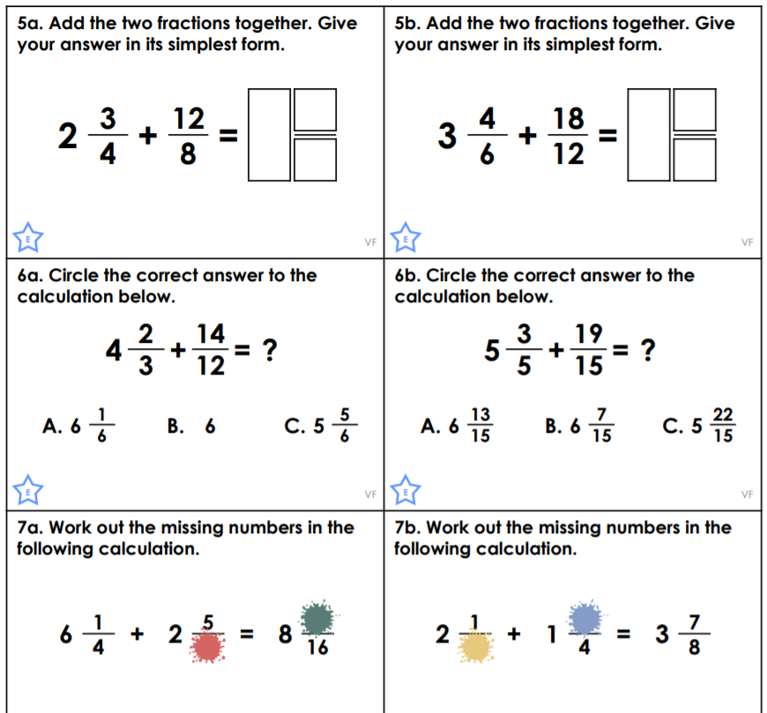

Challenges
