Thursday 2nd July
Converting measures – fluency and problem solving

You have done a great job so far this week with converting measures.
Re-cap – have a go at these:
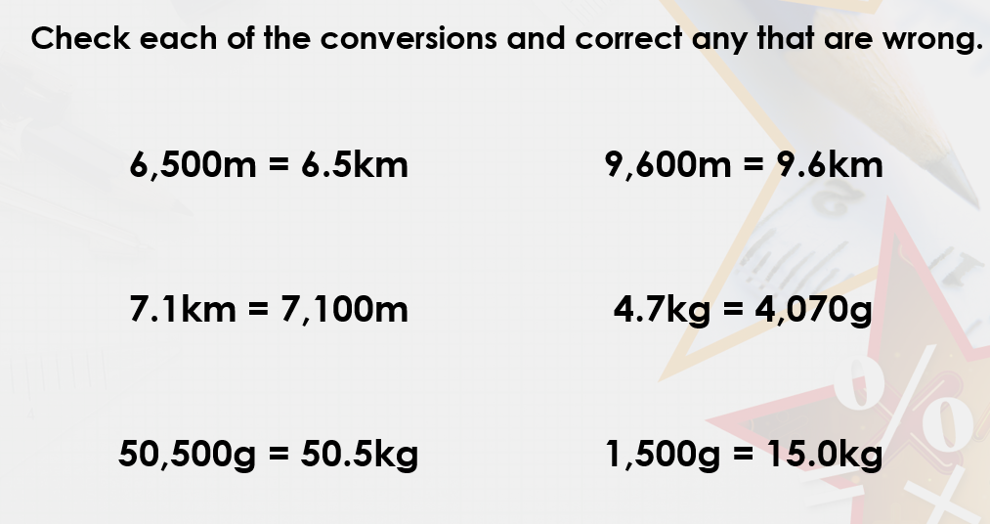

Can you remember what these symbols mean?

> means _________________
< means _________________
= means __________________

We are going to use these symbols to compare measurements.
Example:

True or false?
How can we prove it? We need to convert the kg to g.
To convert 4kg into g, we need to multiply by 1000.
4 x 1000 = 4000g
Therefore the statement above says 4000g is greater than 3,500g.
That is true.

Example 2:
True or false?
Convert 21kg into g by multiplying by 1000.

21 x 1000 = 21000g
21,000 is greater than 210g so the statement is correct.

Your turn:
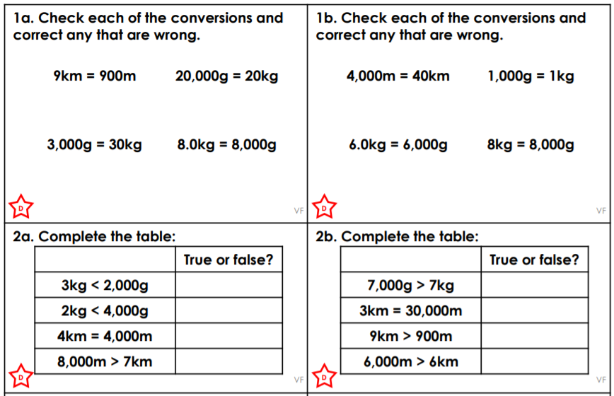
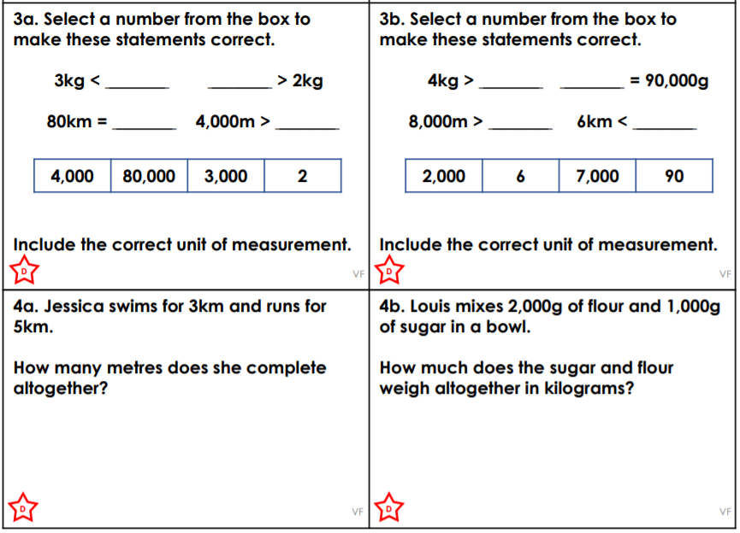

Challenge:
