Thursday 2nd July 2020
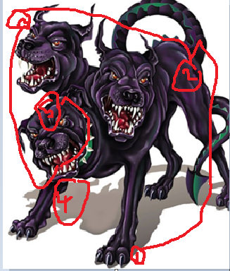
This week you are aware that we are writing a conquering the monster story about Ancient Greek mythical creatures. For today’s English and Friday’s English, please carry on learning the WAGOLL which you started to learn on Tuesday, but we will also learn how to write descriptively.

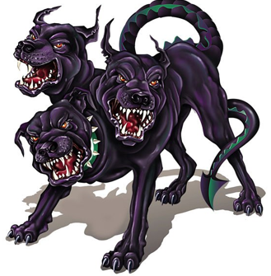
This is Cerberus, a 3 headed dog which protected the underworld and stopped the dead from ever leaving!
I have created my own word bank to support my writing.
Nouns | Adjectives | Verbs
eyes  nose  mouth  teeth  claws  legs  tails | fierce  ferocious  vicious  razor-sharp  violent  aggressive  mauve | snarl  growl  pounce  attack
Now that I have created my own word bank, I will use the lines that have been drawn to help me focus on my writing. I will start at number 1 and then go to number 2 etc.

Razor-sharp, chalk-white claws were a stark contrast to the grubby, bleak ground of the underworld. The deadly claws were as sharp as knives, ready to rip apart anyone or anything which got in their way. The claws would scrape along the ground, a sickening sound for its prey as they knew the end would come.

Can you use the images from the powerpoint and choose a creature? Once a creature has been chosen can you please draw on the creature for each part which you will write about? Create a word bank and start writing your descriptive paragraph!

