Thursday 25th June 2020
Remember when we estimate we can round each number to the nearest 10 or 100. Normally the bigger the number we round to the nearest 100 and the smaller the number we round to the nearest 10.
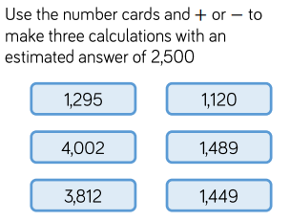
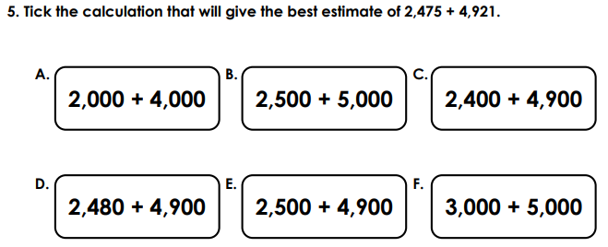
Look at yesterday input if you need reminding.

