Thursday and Friday
Please use the plan from yesterday and start to write up your plan. There is a format saved that you are more than welcome to use (will have to delete the text then write your own information).
Or alternatively, you are able to design your own non-chronological report but just ensure you have all the information on it! Below is a checklist for a non-chronological report.
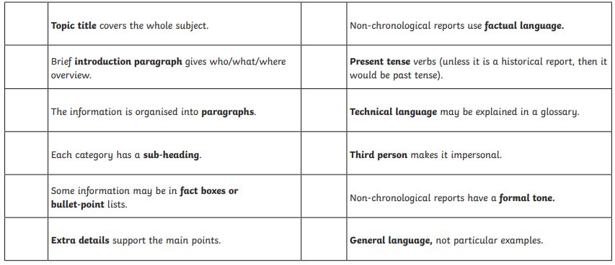
We have written many non-chronological reports so we are looking forward to seeing the finished result!

