Date:____________________________
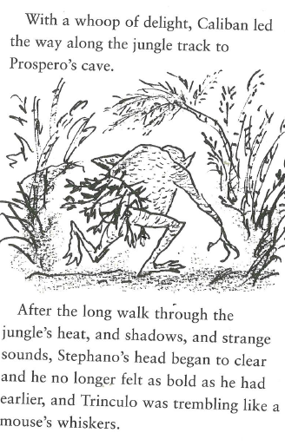
Content Domains: 2d/2b/2g

How do we know that Caliban is excited?
__________________________________________________
What makes Stephano’s head clear?
__________________________________________________
__________________________________________________
Why are Stephano and Trinculo beginning to be afraid?
__________________________________________________
__________________________________________________
Which phrase proves that Trinculo is scared?
__________________________________________________

_______________________________________________________________________________________
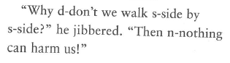
Which one words from this phrase shows that Trinculo is nervous?
_______________________________________________________

_______________________________________________________________________________________
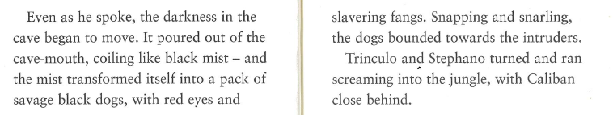
How is the darkness described? Find and copy a phrase __________________________________________
Find and copy 2 ways the mist is described _________________________and _______________________
_______________________________________________________________________________________

