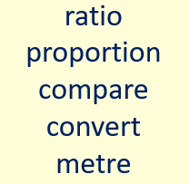

Please use the powerpoint which is attached to help you. This is a new area of maths, which we have not covered.
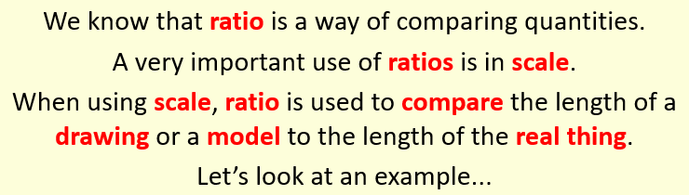

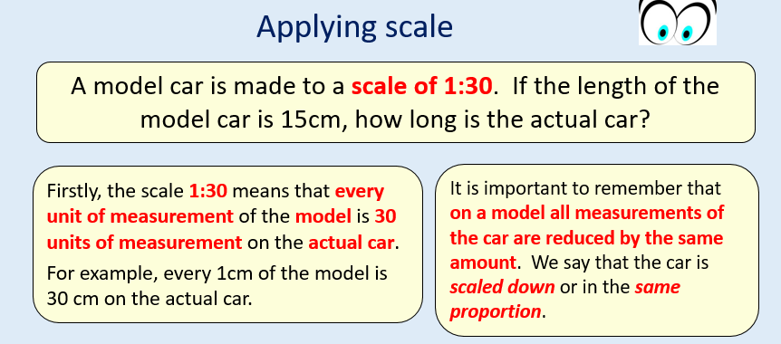

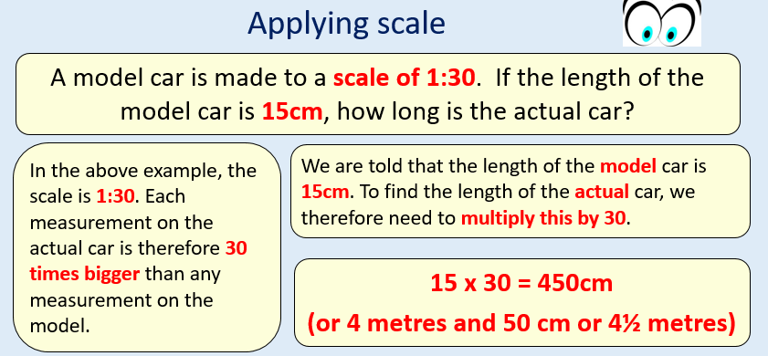

- A lamp post measures 5 cm on a drawing. The scale of the drawing is 1:100. What is the height of the actual lamp post in metres?

- A model of a dinosaur is made to a scale of 1:12. The head of the dinosaur is 8 cm long. What is the length of the head of the actual dinosaur?

- A tennis court is 7 m wide and 21 m long. A drawing is made of the court using a scale of 1:200. What is the width of the court on the drawing?

https://www.bbc.co.uk/bitesize/guides/znnycdm/test
Can you test your knowledge of ratio and proportion? How did you do? Can you keep improving your score?
