Fractions of Objects
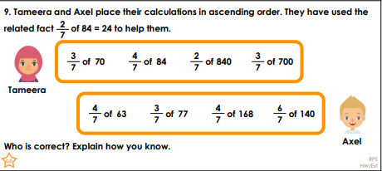
- 6/5 of 30 =
- 4/9 of 54 =
- 9/10 0f 60 =
- 3/4 of 24 =
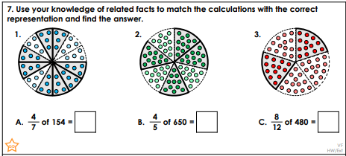
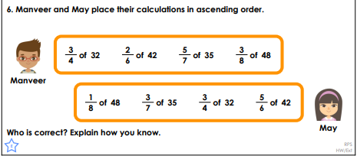
- 2/3 of 33 =

